Project Title: Self Service Ticketing System for Train

Developer: Shaaban, Mohammed Najib Ahmed

Table of Contents

1.0 Introduction 3

2.0 Problem Statement 3

3.0 Objectives 4

4.0 Scope 5

5.0 Project Plan 7

6.0 Requirements 13

6.1 Survey 13

6.2 Comparison with current existing train systems. 16

6.3 Functional Requirements 16

6.4 Non-Functional Requirements 17

6.5 Constraints 17

6.5.1 Business Constraints 17

7.0 Modelling 18

7.1 Use Case Diagram 18

7.1.1 Use Case Description 19

7.2 Entity Relationship Diagram (ER) 20

7.3 Class Diagram 21

7.4 Activity diagram 22

7.5 Sequence Diagram 24

8.0 Design 25

8.1 Data Design 25

8.2.1 Component Design Diagram 28

8.3 Architecture Design 29

8.4 Interface Design 30

8.4.1 Home Page 30

8.4.2 About Us Page 31

8.4.3 Help Page 32

8.4.4 Contact Us Page 32

8.4.5 User Details Page 33

8.4.6 Destination Page 34

8.4.7 Date and Time Page 35

8.4.8 Pick Seat Page 37

8.4.9 Payment Page 39

8.4.10 Final Print Page 40

8.4.11 Ticket Receipt 41

8.4.12 Train Ticket 41

8.4.13 Links Used in Making the User Interface Design 41

8.5 Internal Logic 42

8.5.1 Flowchart 42

8.5.2 Pseudocode 51

9.0 Testing 53

9.1 Testing Functional Requirements 53

9.2 Testing Non-Functional Requirements 54

9.3 Decision Tables 55

9.3.1 User Enter Details 55

9.3.2 User Picks Type of Ticket 55

9.3.3 User Picks the Payment Method 56

9.3.4 User Print Ticket or Print Receipt 56

9.4 Test Case 57

9.4.1 User Enter Details 57

9.4.2 User Picks Type of ticket 63

9.4.3 User Picks the Payment Method 67

9.4.4 User Print Ticket or Print Receipt 71

9.4.5 Display About Us, Contact Us and Help page 74

9.4.6 Display Routes Map and the Fare for the Destination 76

9.4.7 Shows Seats Availability 77

9.4.8 Display Name and E-mail Address in Train Ticket and Train Receipt. 78

Reference 79

# 1.0 Introduction

Self-Service Ticketing System for Train is a system that offers useful information and service to users that could allow them to conveniently plan on their future train journey and book tickets on their own. There is no specific and narrow target audience as the system can be used by anyone that wishes to buy train tickets easily. The system is also used by administrators to manage, oversee and maintain the system.

A Self-Service Ticketing System for Train usually contains useful features that could ease the users to book their train tickets. Some features included in the system are; the ability for user to pick a destination, pick and reserve desired seat and make online payment for the ticket.

The Self-Service Ticketing System for Train is widely used in Malaysia, which allows Malaysians to easily book train tickets and plan on their future train journey. Some commonly used websites for train tickets booking are www.ktmtrain.com and www.ktmb.com.my. These platform for these systems is Web-based, and users can easily access them on web browsers.

The team were asked to create a Self-Service Ticketing System for Train in 13 weeks. This document introduces a precise description of the capabilities provided by the system. It will explain important aspects of the system such as the features of the system and the constraints under which the system must operate in. This document is intended for both the stakeholders and the developers of the system, as it could provide key information on the system which can be used in the future.

# 2.0 Problem Statement

Public transportation plays an important role to the community around the world. The train transportation is used daily by people all around the world even in Malaysia. It was found that 1.3 billion train trips were recorded in 12 months during the year 2015 (Ellis, 2015). It offers convenience and many advantages to the community in plenty aspects such as reducing traffic congestion and reducing air pollution. Even though the train system offers plenty of advantages there are some problems that should not be overlooked. Living in this vastly improving world with technology being developed daily, it is a golden opportunity to improve the train system to fully optimize the system and provide more convenience to the users.

Here are lists of problems that the team discovered with the train system:

* Train users could not buy tickets 24 hours a day
* Most of the time train users must wait in a long queue to buy a ticket
* Limited payment method for train seat booking
* Train companies have to hire human workers to work in the ticket counter daily
* Train users tend to lose ticket and receipt easily
* Train users has limited ways to check available train routes
* Train users has limited ways to check train schedule
* Train users has to go to a train station to book a ticket

# 3.0 Objectives

For our Self-Service Ticketing System for Train, the team believe that it is possible to create a digital ticketing system that could tackle most of the problems that the current train system is having now. The team also took into our consideration the constraints and limits imposed to outline a general set of objectives predominantly considered to be feasible and within capability of being released. The system incorporates of many delicate functions that may be undertaken by both users and administrations. Following expectations, a number of objectives were outlined to better visualize the design and implementation of the system.

The objectives are listed as follows:

* The system allows train users to book ticket any time of the day

-the ‘24/7’operation of the system allows train users to easily book train ticket anytime.

* Train users can pay for the train ticket when using the system

-this useful feature could prevent users from going through long queues at the station to buy tickets.

* The system offers multiple payment options for train users to choose from

-train users can easily pick any payment whichever they find convenient. The payment method will be decided based on the survey that will be conducted.

* The system allows the process of diminishing the hiring of human workers

-existence of the software would allow train companies to hire fewer human workers as the system could be used more frequently in purchasing tickets from train users.

* The system could print out receipt and ticket information.

-with this feature train users can easily access their ticket information and receipt without having to worry of losing it later on.

* Train users can easily check the train routes with the system

-such feature would allow train users to plan on their train journey.

* Train users can check the train schedule with the system

-such feature would allow train users to plan on their train journey.

* Train users can book a ticket anywhere with the system

-train users could conveniently buy tickets without having to go to the train station every time.

# 4.0 Scope

The team decided it is best to identify the scope of the software before starting to develop it. According to Sami, scope contains features and functions in a product, system or result. (Sami, 2017). For the scope of our software, we decided to list out few key points such as the programming language used that could help us to benefit from when developing said software.

* Programming language used

We found out that that picking the right programming language is important in developing a software. We had to make sure that every team member is familiar with the language chosen to allow smooth process in developing said software. After much discussion, the team decided to use the programming language Java for the software. The team made such decision as the team is confident that Java could deliver our need to code our program smoothly.

* Platform

For our Self-Service Ticketing System for Train, the team decided that the software is a standalone system. A standalone system usually does not necessarily require network connection for it to function. The team discovered that it is the best option to choose from to develop the software. The team could benefit from choosing this option, as every team member is quite familiar in creating standalone system. The team also found that the benefits of using this platform outweighs the liabilities.

* Hardware

Since the Self-Service Ticketing System for Train is a standalone system, the team found out that any computer that could install the program can use this hardware. A benefit of having such system is the ease of owning the software; user can just install it in the computer and run it right after.

* Software

The team believe that the Self-Service Ticketing System for Train the software can run at any operating system and it does not require any other special software to run the program except the train system as it a standalone system.

* User

The team found out that there would be two core users for the Self-Service Ticketing System for Train User.

1. Administrator

The administrators are usually the ones that are responsible for managing, overseeing and maintaining the software.

1. Common User

The common user refers to the ‘customers’ or any other users that use the program. There is no specific target audience for the users as it can be used by anyone that wants to book a train in the system.

* Time frame

The time allocated for the team to complete the Self-Service Ticketing System for Train User is 13 weeks.

* Function of the system

The team has to make sure that the function of the system matches the objectives that the team wants to achieve.

1. System users can gain more information on the Self-Service Ticketing System by referring to the ‘About Us’ segment on the system.
2. System users can get most of their questions answered with less hassle by looking at the ‘Help’ segment on the system.
3. System users can gain the contact number of the train company for more enquiries on the train system.
4. System users can have their information such as their name and email printed on the train ticket and the receipt.
5. System can display routes map and the fares for the destination.
6. System users can check seats availability when purchasing a ticket with the system.
7. System users has the option to select different dates when purchasing a ticket with the system.
8. Multiple payment method will be offered for users to pay their train tickets.
9. Train ticket and receipt can be printed by train users after purchasing their train tickets.

# 7.0 Modelling

## 7.1 Use Case Diagram

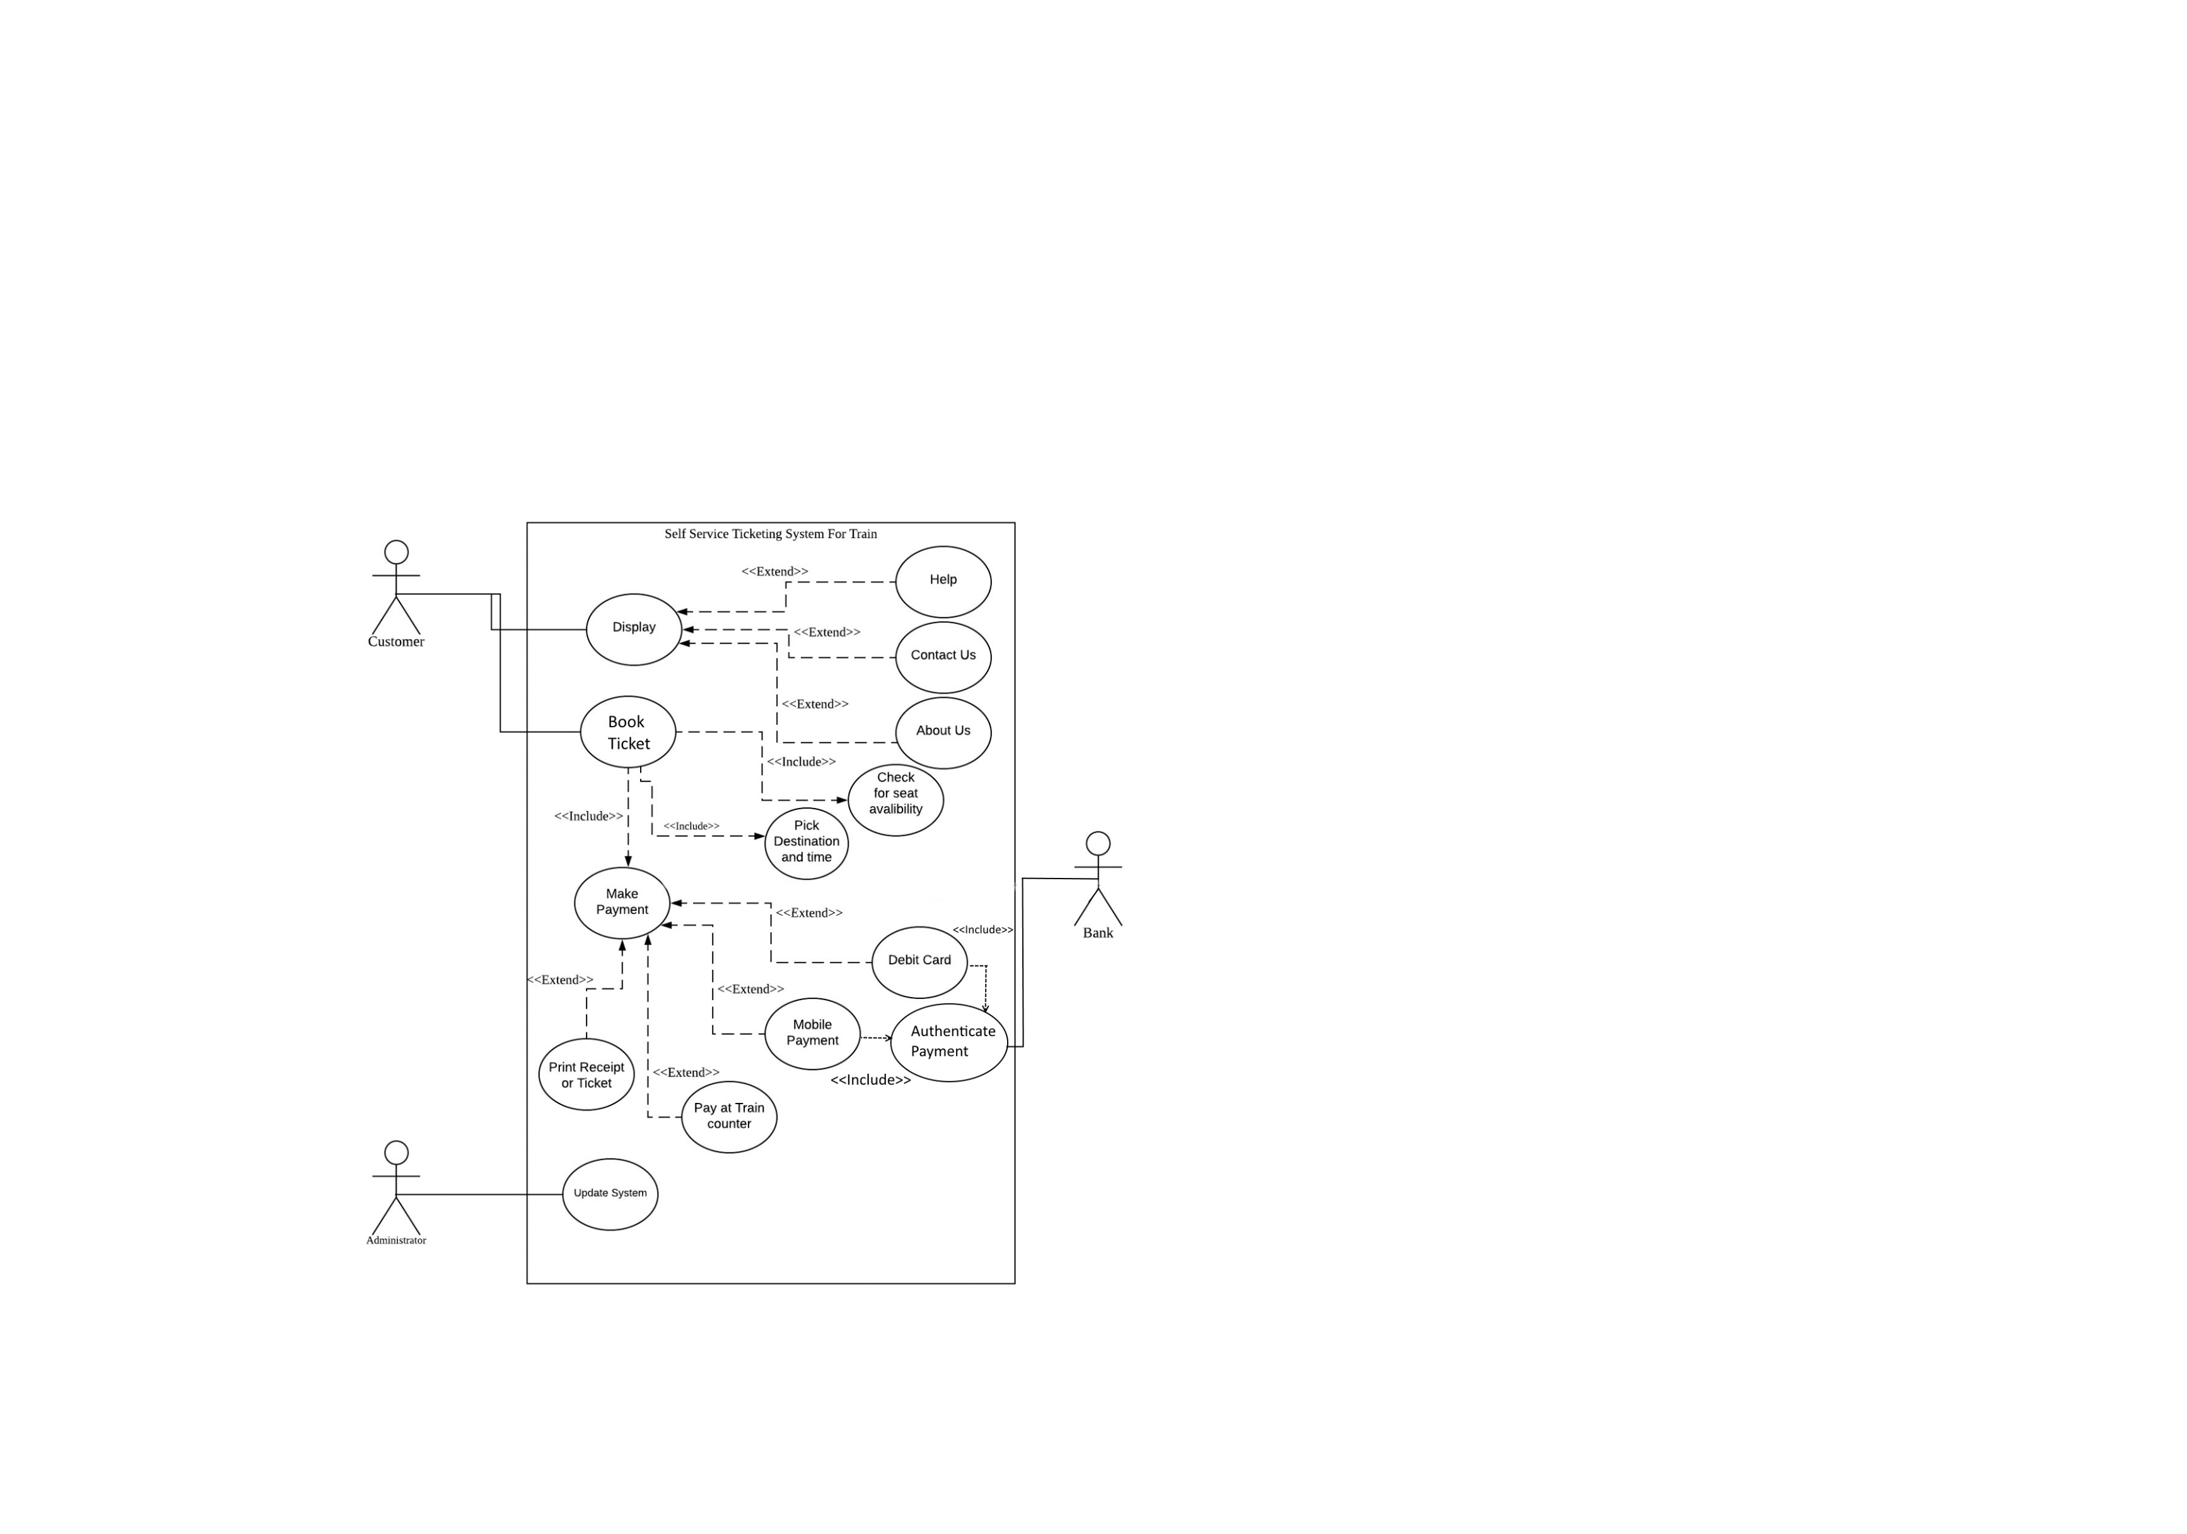

### 7.1.1 Use Case Description

|  |  |
| --- | --- |
| Use Case Name: | Self Service Ticketing System for Train |
| Created By: | Shaaban, Mohammed Najib Ahamd |
| Date Created: | 23-7-2018 |
| Description: | This use case allow user to log in into the system to access the relevant functions according to the user roles which divide into the Customer and the system administrator. To start the system all user must input valid information desired by the system. After the customer has start in the system home page will display showing the various service for the customer. The booking must include payment and the payment can be done by different payment method. After payment, user can print out the receipt or ticket. |
| Primary Actor: | Customer, Administrator |
| Secondary Actor: | Bank |
| Precondition: | 1. The customer must have valid information |
| Postcondition: | 1. The system display the relevant homepage |

## 7.2 Entity Relationship Diagram (ER)

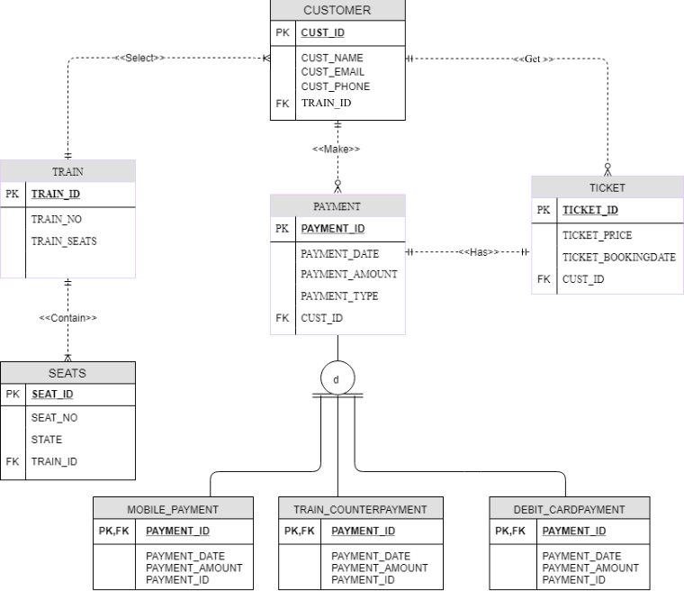

The diagram above shows the Entity Relationship (ER) diagram of the Self-Service Ticketing for Train system. Every entity plays an important role in the process of executing the system. Based on the relationships, it can be said that a customer can select one train per transaction and a train can contain one to many customers. Also, customer could have zero to many tickets and a ticket can only be owned by a single customer. A customer can also make zero to many payments and a single payment can only be made by one customer. A ticket only has one payment and a payment can only be made for one ticket. Lastly, a train can contain many seats and a seat can only be in one train.

## 7.3 Class Diagram

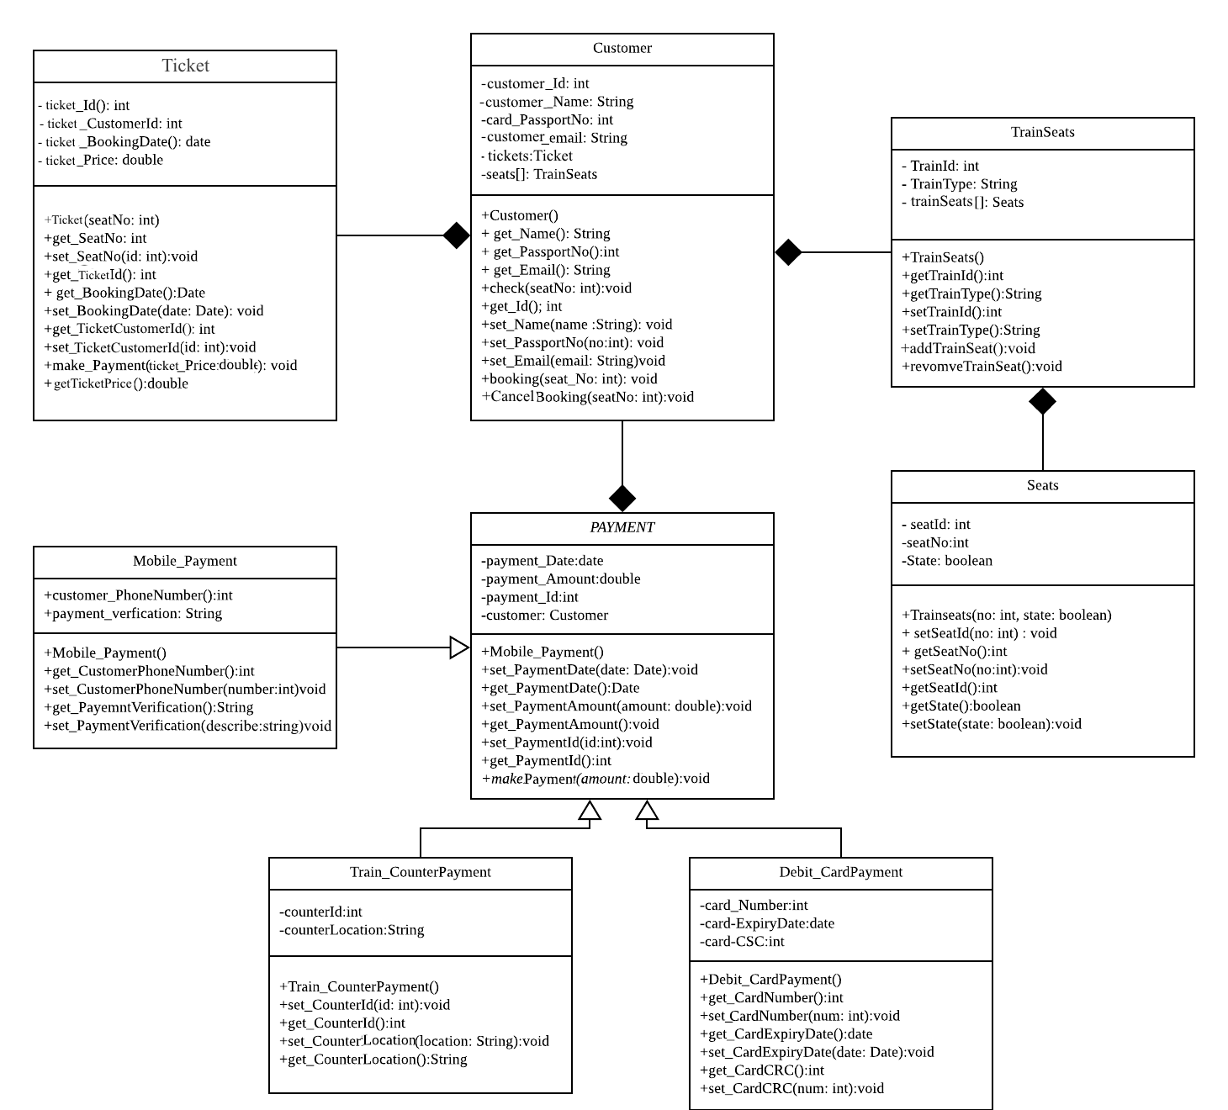

The figure above shows the Class Diagram of the Self-Service Ticketing System for Train. There are some noticeable relationships in the diagram. Customer entity has strong relationship with Ticket and Trainseats entity. PAYMENT entity has strong relationship with Customer entity. Also, Mobile_Payment Train_CounterPayment and Debit_CardPayment inherits from PAYMENT.

## 7.4 Activity diagram

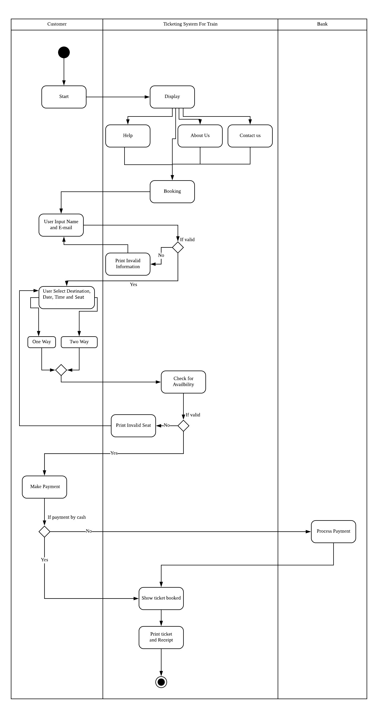

The figure above is the Activity Diagram for Self-Service Ticketing System for Train.

There are three different columns in the diagram which are Customer column, Ticketing System for Train column and Bank column. These columns contain the roles of the system, the customer and the bank. The diagram starts off with the system showing three sections; About Us, Help and Contact Us and then the Customer will be directed to the Booking Section. Customer could also go directly to the Booking Section without having to go to the previous three sections. The customer then has to input their name and E-mail in the system, and the system will decide if the information is valid or not. After that, user has to pick their destination, date and time. User then has the choice to buy a one-way ticket or a two-way ticket. After that, user can pick their desired seat in the train. The system will then check for availability of the user's choices. The customer then has to make payment, and if it is by cash user will be directed straight into the booked ticket section. If not, the user has to make payment with the bank and the bank would process the payment. The diagram ends with the system allowing the user to print ticket or receipt.

## 7.5 Sequence Diagram

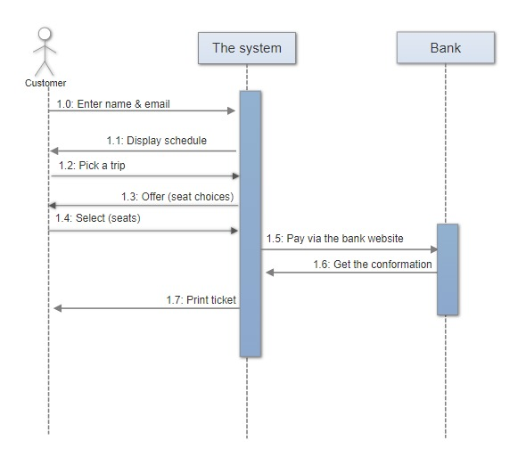

The diagram above shows the Sequence Diagram of the Self-Service Ticketing for Train.

1.0: User enter their name and E-mail in the system.

1.1: The system shows the schedule of the available time and date for the train.

1.2: Customer picks a trip and also other details such as the time and date.

1.3 The system will show the available seats for customers to choose from.

1.4 Customer has to select desired seats to book.

1.5: If payment requires transaction with the bank, the bank would process the payment.

1.6: System receives confirmation of the payment from the bank.

1.7: System can print out receipt and the train ticket.

# 8.0 Design

We know from our prior research, the stockholders’ requirements and survey we found that design is one of the most important parts side-by-side with the system functions to focus on during implementing the system to fully optimise our Self-Service Ticketing System for Train. We decided to conduct the design part among the team members based on their skills to make our system perfect to be used frequently.

## 8.1 Data Design

In data design section we provide the data dictionary which explains the ERD with its attributes according to the diagram’s entities to make it easy to understand and execute during the implementation phase.

|  |  |  |  |  |  |
| --- | --- | --- | --- | --- | --- |
| TABLE NAME | ATTRIBUTE NAME | CONTENTS | TYPE | PR/FK | FK REFERENCE TABLE |
| CUSTOMER | CUST_ID | Customer ID | Int(1000) | PK |  |
|  | CUST_NAME | Customer name | Varchar(4) |  |  |
|  | CUST_EMAIL | Customer email | Varchar(20) |  |  |
|  | TRAIN_ID | Train ID | Int(1000) | FK | TRAIN |

In the customer table, customer will have their own ID, name and email. The customer ID is primary key in this table. Customer ID helps to identify the right customer in the database. The train ID in the table is a foreign key. Foreign key in the table helps to know which train the customer take.

|  |  |  |  |  |  |
| --- | --- | --- | --- | --- | --- |
| TABLE NAME | ATTRIBUTE NAME | CONTENTS | TYPE | PR/FK | FK REFERENCE TABLE |
| TRAIN | TRAIN_ID | Train ID | Int(1000) | PK |  |
|  | TRAIN_NO | Train Number | Varchar(8) |  |  |

In the train table, each train have their own ID and train number. Train ID in the table is for identify each train. Train number in the train table is identify which train used for traveling.

|  |  |  |  |  |  |
| --- | --- | --- | --- | --- | --- |
| TABLE NAME | ATTRIBUTE NAME | CONTENTS | TYPE | PR/FK | FK REFERENCE TABLE |
| SEATS | SEAT_NO | Seat Number | Int(100) | PK |  |
|  | STATE | Seat Status | Varchar(15) |  |  |
|  | TRAIN_ID | Train | Int(1000) | FK | TRAIN |

In the seats table, the table has seat number, state of the seat and train ID. Seat number is a primary key in the table for getting know seat in the train.  The seat status is to get know whether the seat is empty or not. Train ID is the foreign key in seats table. The train ID is to identify the seats are belongs to which train.

|  |  |  |  |  |  |
| --- | --- | --- | --- | --- | --- |
| TABLE NAME | ATTRIBUTE NAME | CONTENTS | TYPE | PR/FK | FK REFERENCE TABLE |
| TICKET | TICKET_ID | Ticket ID | Int(1000) | PK |  |
|  | TICKET_PRICE | Ticket Price | Ticket(10) |  |  |
|  | TICKET_BOOKINGDATE | Ticket Booking Date | Varchar(10) |  |  |
|  | CUST_ID | Customer ID | Int(1000) | FK | CUSTOMER |

In the ticket table, ticket ID is the primary key to identify every ticket. The price of the ticket and the

booking date of the ticket is the detail of the ticket that customer bought. The ticket will be identified by using customer ID to know the ticket was bought by which customer.

|  |  |  |  |  |  |
| --- | --- | --- | --- | --- | --- |
| TABLE NAME | ATTRIBUTE NAME | CONTENTS | TYPE | PR/FK | FK REFERENCE TABLE |
| PAYMENT | PAYMENT_ID | Payment ID | Int(1000) | PK |  |
|  | PAYMENT_DATE | Payment Date | Varchar(12) |  |  |
|  | PAYMENT_AMOUNT | Payment Amount | Int(10) |  |  |
|  | PAYMENT_TYPE | Payment Type | Varchar(10) |  |  |
|  | CUST_ID | Customer ID | Int(1000) | FK | CUSTOMER |
| TRAINCOUNTER_PAYMENT | PAYMENT_ID | Payment ID | Int(1000) | PK,FK | PAYMENT |
| MOBILE_PAYMENT | PAYMENT_ID | Payment ID | Int(1000) | PK,FK | PAYMENT |
| DEBIT_CARD_PAYMENT | PAYMENT_ID | Payment ID | Int(1000) | PK,FK | PAYMENT |
|  | CARD_ID | Card ID | Int(1000) |  |  |

In the payment table, Payment ID is used to identify every payment that made by every customer. The date and the amount of payment are the detail of the payment. The payment type can be either train payment, debit card payment or mobile payment. If payment type is debit card payment, the debit card ID that used by customer will be stored. Customer ID is the foreign key in the payment table to identify the payment was made by which customer.

8.2 Component & Deployment Design

In this section we show both of the component diagram and deployment diagram with more expanded explanation in their own sub-sections. Component diagram help to model the implementation of our system and the deployment diagram help to model the implementation environment of it.

### 8.2.1 Component Design Diagram

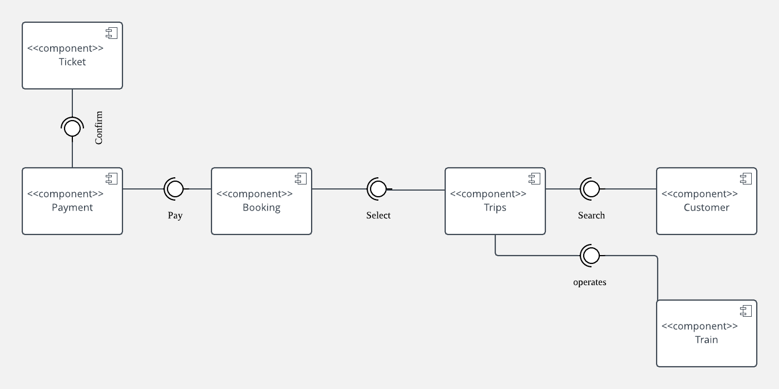

The figure above shows the Component Diagram of the Self-Service Ticketing System for Train. It covers every aspect of the system's required function as planned. It’s noticeable that the component “Trips” retrieves its time and date from the component “schedule”. Also, the Customer get the ticket from the component “Ticket” after the payment is confirmed.

8.2.2 Deployment Design Diagram

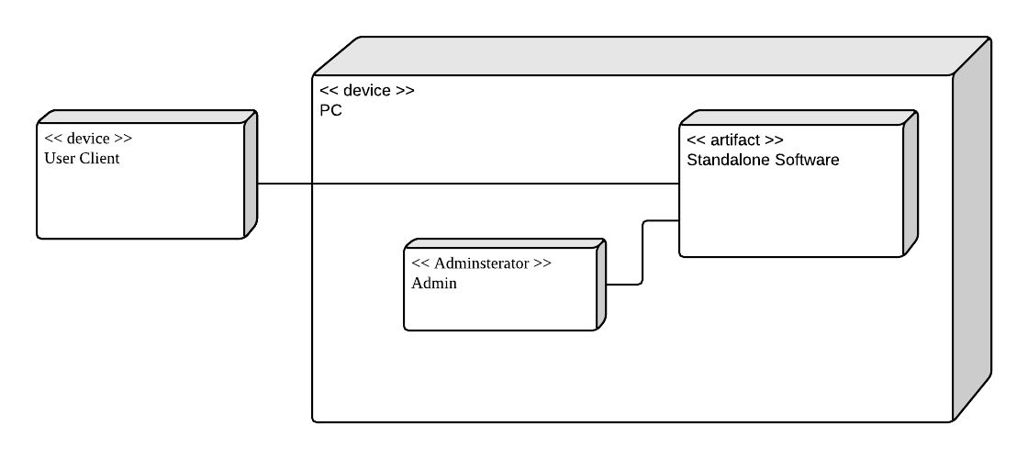

The diagram above shows the Deployment Diagram of the Self-Service Ticketing for Train. It describes the physical deployment of information generated by the software program on hardware components. Every node plays an important role in the process of executing the system like the application server. The diagram illustrates that all of the nodes are interact with the application server to perform its functions.

## 8.3 Architecture Design

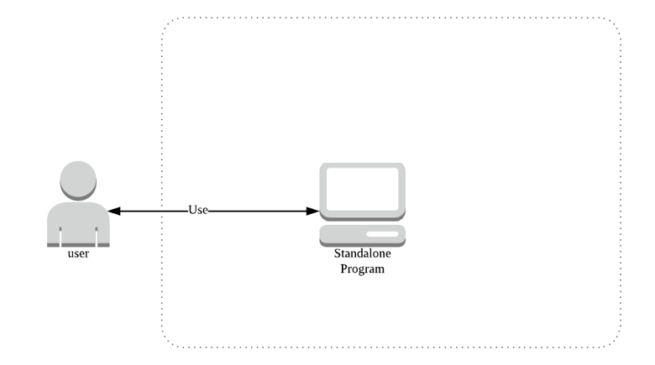

The architecture diagram provide a graphical representation of the system’s concepts that are part of the system’s architecture elements and components, the diagram design below shows the architecture design of Train Ticketing System. The customer is the only user to use the standalone program.

## 8.4 Interface Design

Based on our research designing of Train Ticketing System with GUI is an advantage for the system because the common passenger can use it and understand it easily without any difficulties. Making our design user-friendly and reliable is important as its functions. In the upcoming sub-sections we explained every page and what it does in a more expandable way.

### 8.4.1 Home Page

The figure below is a graphical representation of the Home page. In this page, user can choose to go to the About Us Page, Help Page, Contact Us Page and Booking Page by clicking the button of the desired path and the program will direct the user to the desired page.

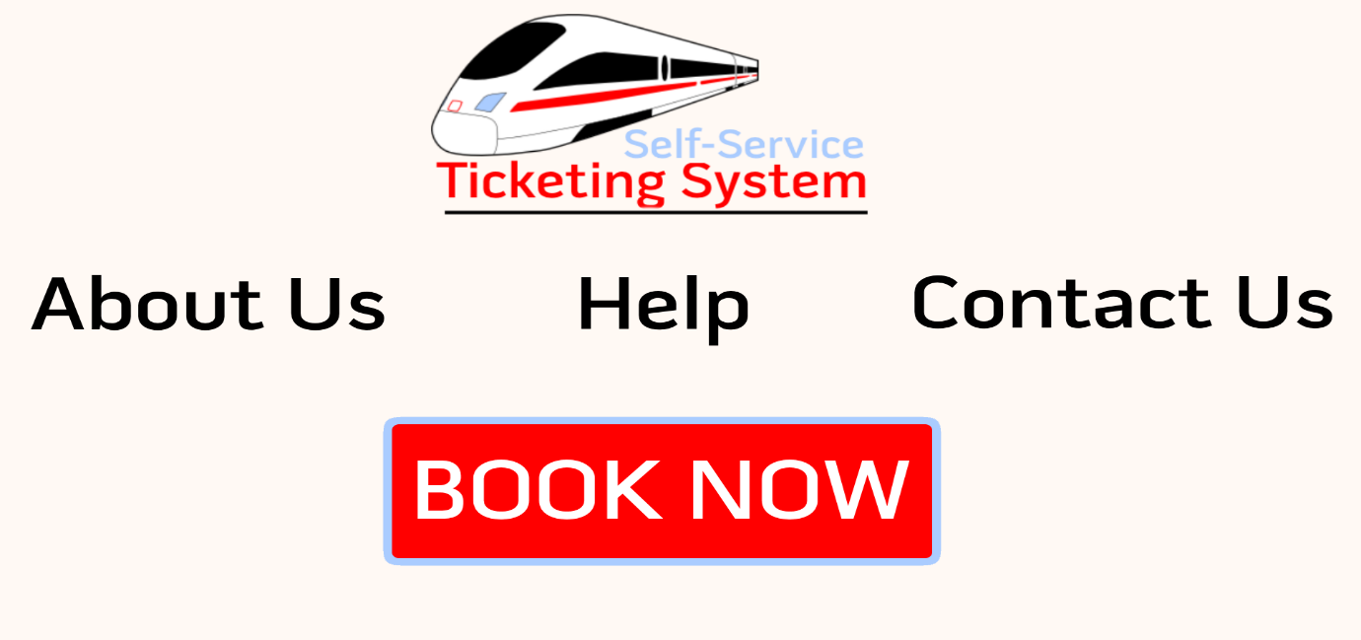

### 8.4.2 About Us Page

The figure below is a graphical representation of the About Us page. In this page, user can learn more about the train company. User can also choose to go to the Help Page, Contact Us Page and Booking Page by clicking the button of the desired path and the program will direct the user to the desired page.

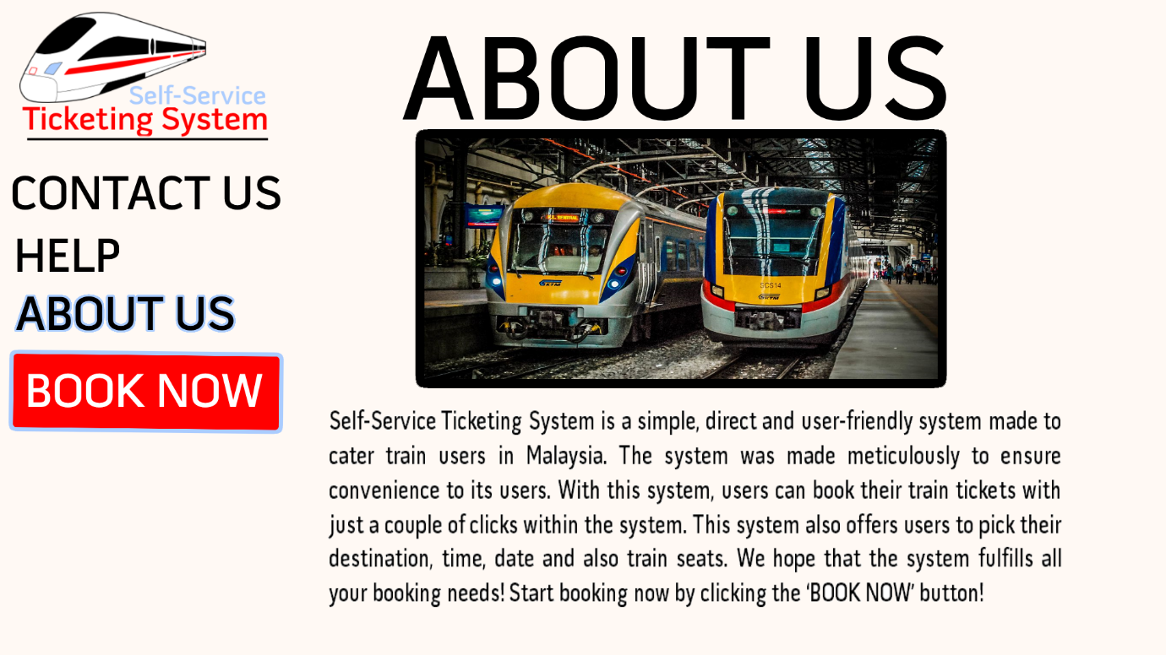

### 8.4.3 Help Page

The figure below is a graphical representation of the Help page. In this page, user can learn more about the system and may have their questions regarding the system answered. User can also choose to go to the About Us Page, Contact Us Page and Booking Page by clicking the button of the desired path and the program will direct the user to the desired page.

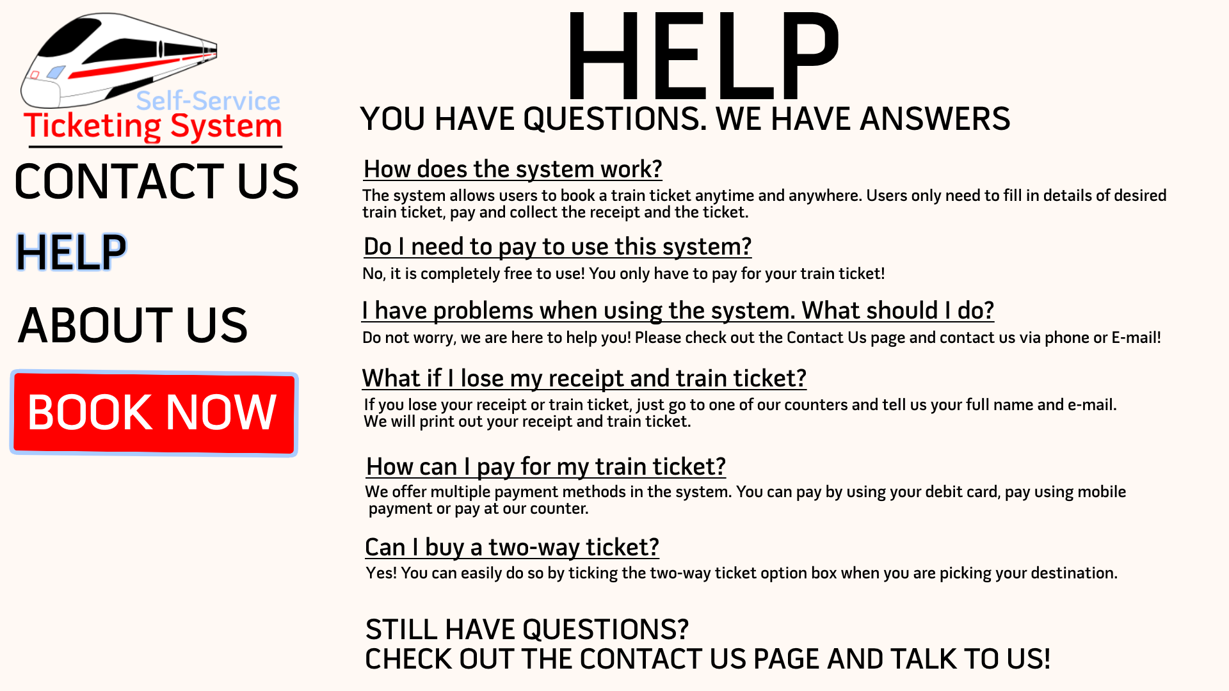

### 8.4.4 Contact Us Page

The figure below is a graphical representation of the Contact Us page. In this page, user can gain contact details of the train company if they wish to contact the train company. User can also choose to go to the Help Page, About Us Page and Booking Page by clicking the button of the desired path and the program will direct the user to the desired page.

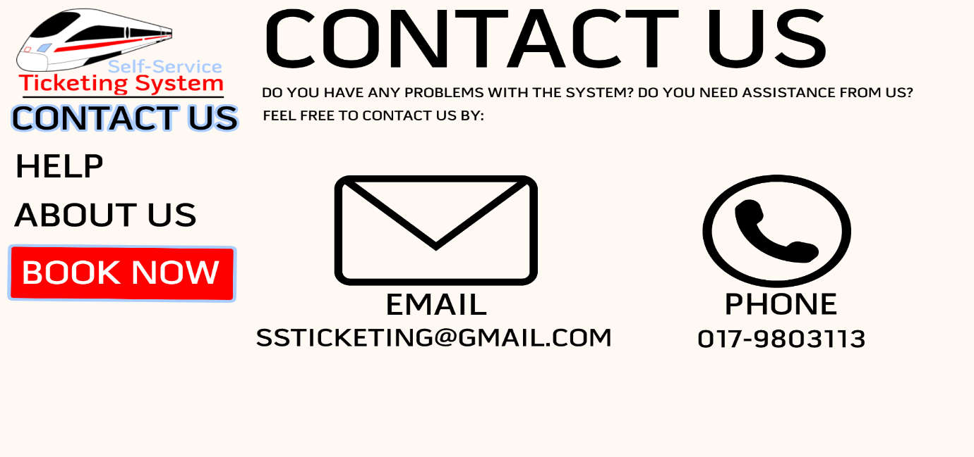

### 8.4.5 User Details Page

The figure below is a graphical representation of the User Details page. In this page, user has to type in the user’s full name and E-mail address and then press continue to proceed to the next page. If there is an error in the input, the program will the detect the error and asks the user to put in the details again. If the user decided to cancel booking, user can press the Cancel Book button and will be redirected back to the Home page.

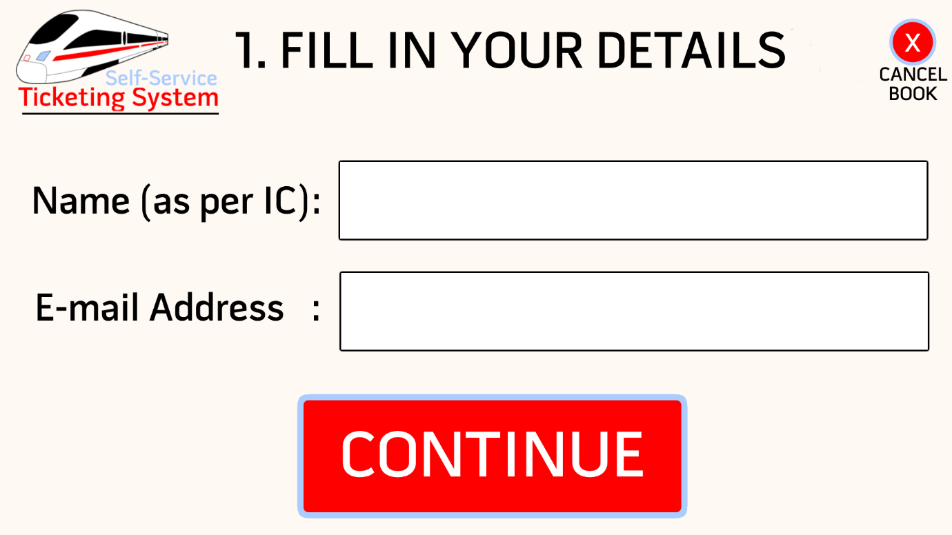

### 8.4.6 Destination Page

#### 8.4.6.1 Destination Page 1

The figure below is a graphical representation of the Destination page. In this page, user has to pick the start destination and stop destination and then press continue to proceed to the next page. If there is an error in the input, the program will the detect the error and asks the user to choose again. User also needs to pick the ticket type; one-way ticket or two-way ticket. If the user decided to cancel booking, user can press the Cancel Book button and will be redirected back to the Home page. And if the user decided to go back to the previous page, user can press the Back button and the program will redirect the user to the previous page.

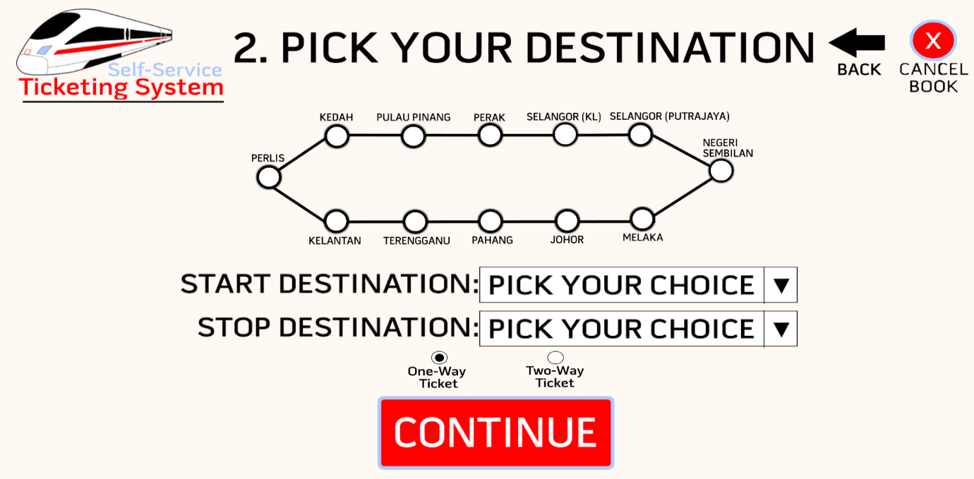

#### 8.4.6.2 Destination Page 2

The figure below shows the method of user choosing a destination. User can access this list by pressing the Pick Your Choice box and user can scroll through the destinations and click on the desired destination.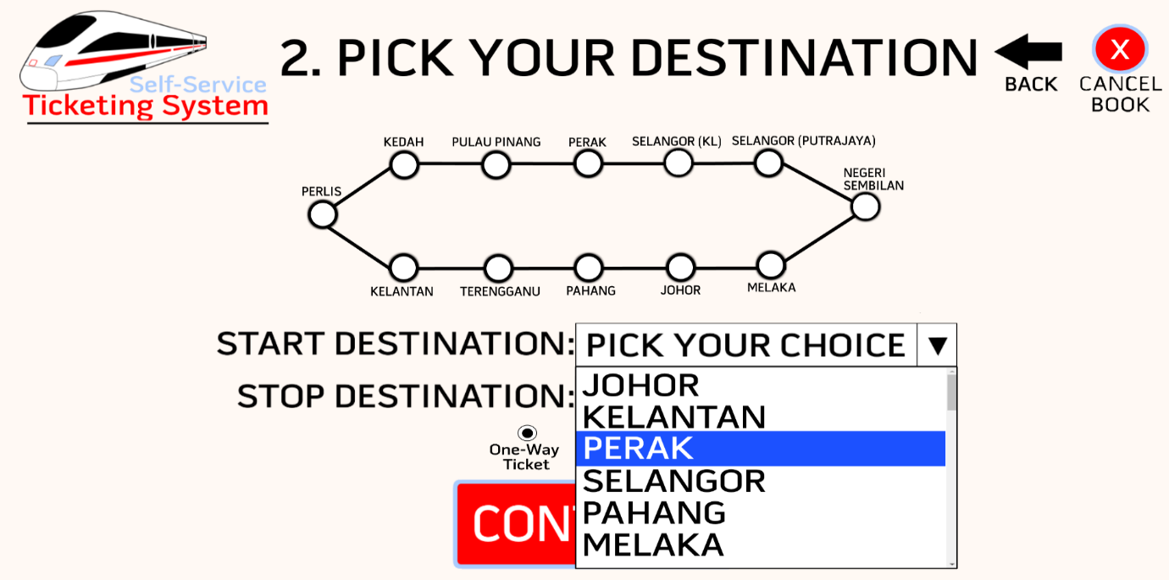

### 8.4.7 Date and Time Page

#### 8.4.7.1 Date and Time Page 1

The figure below is a graphical representation of the Date and Time page. In this page, user has to pick the date and time and then press continue to proceed to the next page. If there is an error in the input, the program will the detect the error and asks the user to choose again. If the user decided to cancel booking, user can press the Cancel Book button and will be redirected back to the Home page. And if the user decided to go back to the previous page, user can press the Back button and the program will redirect the user to the previous page.

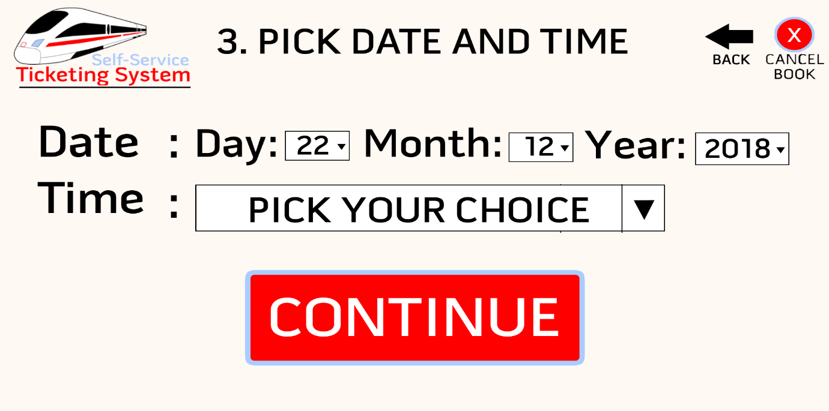

#### 8.4.7.2 Date and Time Page 2

The figure below shows the method of user choosing date and time. User can access the list of choices by pressing the boxes in the page and user can scroll through the choices and click on the desired day, month, year and time.

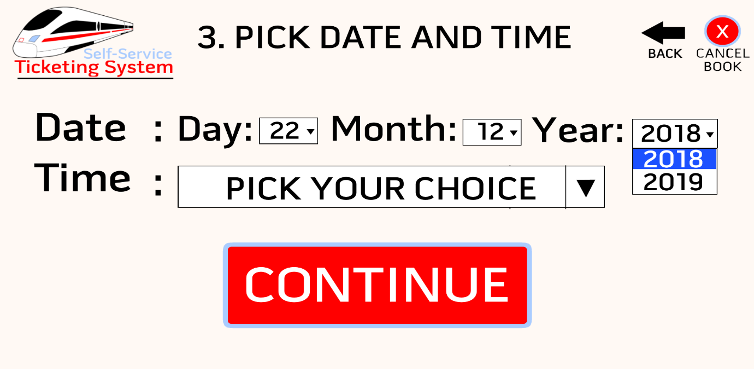

#### 8.4.7.3 Date and Time Page 3 (Depart)

The figure below shows the Date and Time page that will be displayed when the user wants to book a two-way ticket. In this page, user can choose the date and time for the depart train journey. The page works exactly like the one-way ticket Date and Time Page.

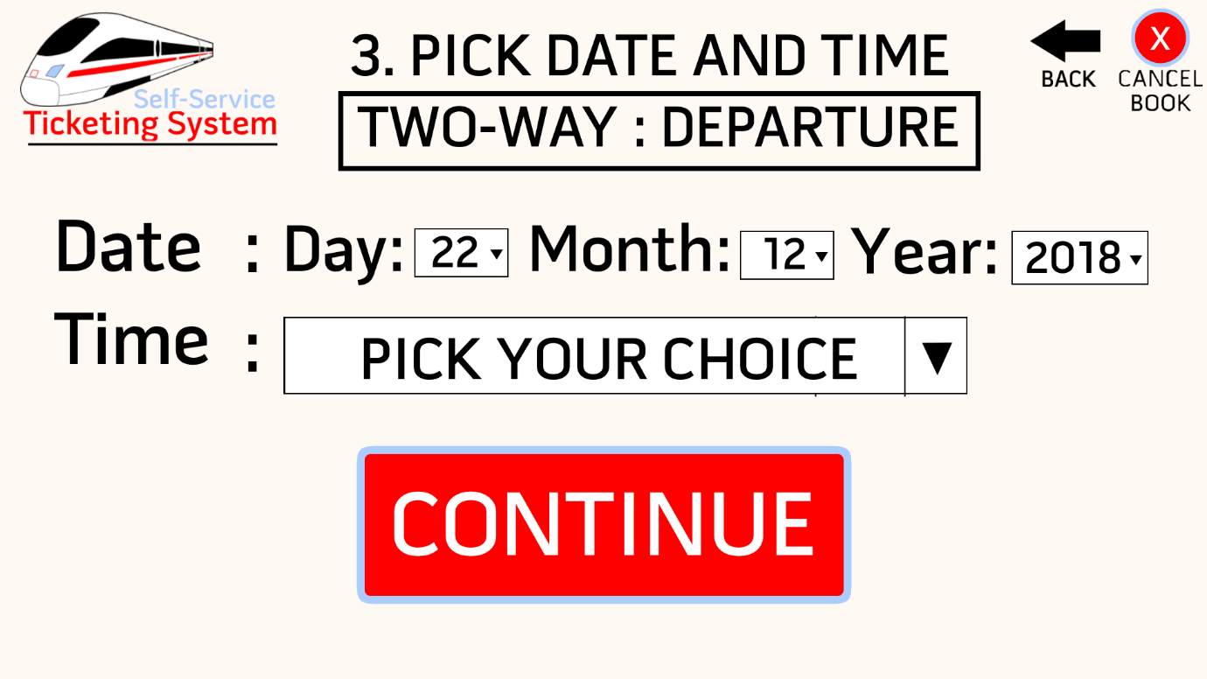

#### 8.4.7.4 Date and Time Page 3 (Return)

The figure below shows the Date and Time page that will be displayed when the user wants to book a two-way ticket. In this page, user can choose the date and time for the return train journey. The page works exactly like the one-way ticket Date and Time Page.

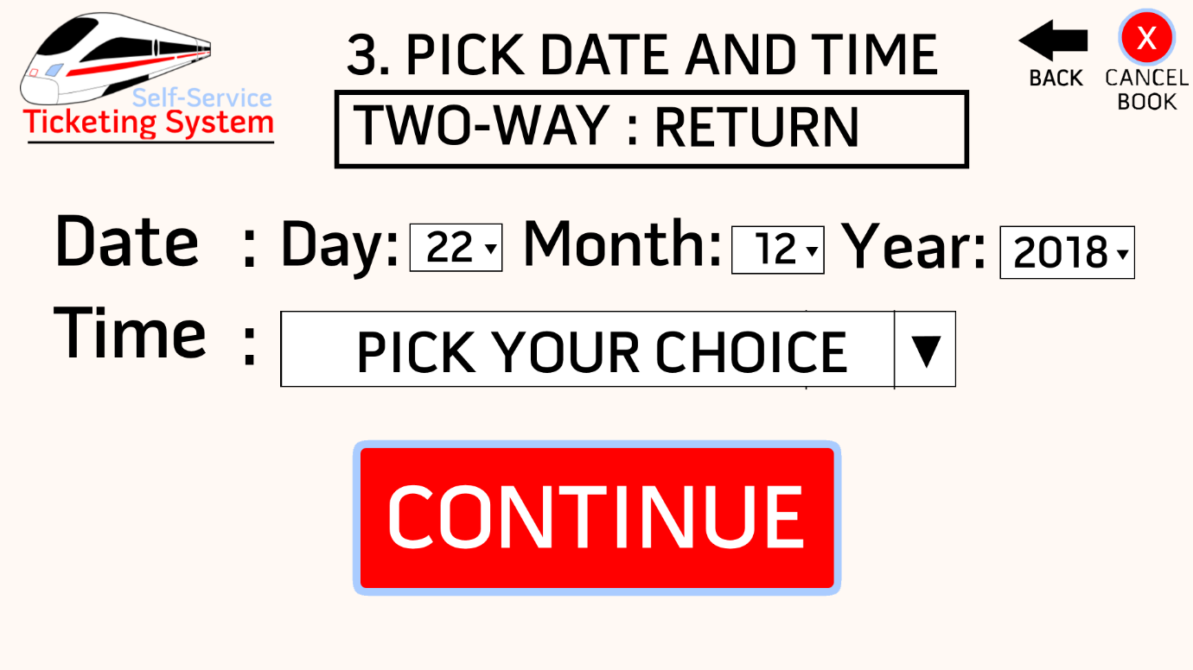

### 8.4.8 Pick Seat Page

#### 8.4.8.1 Pick Seat Page 1

The figure below is a graphical representation of the Pick Seat page. In this page, user has to pick the desired seat and then press continue to proceed to the next page. If there is an error in the input, the program will the detect the error and asks the user to choose again. The available seat boxes will be displayed in white, and the occupied seat boxes will be displayed in red. When the user chooses an available seat and clicks on it, the box will turn green to indicate the selection of the user. The details of the user’s choices for train journey will be displayed on the left side of this page for the user to conveniently refer to. If the user decided to cancel booking, user can press the Cancel Book button and will be redirected back to the Home page. And if the user decided to go back to the previous page, user can press the Back button and the program will redirect the user to the previous page.

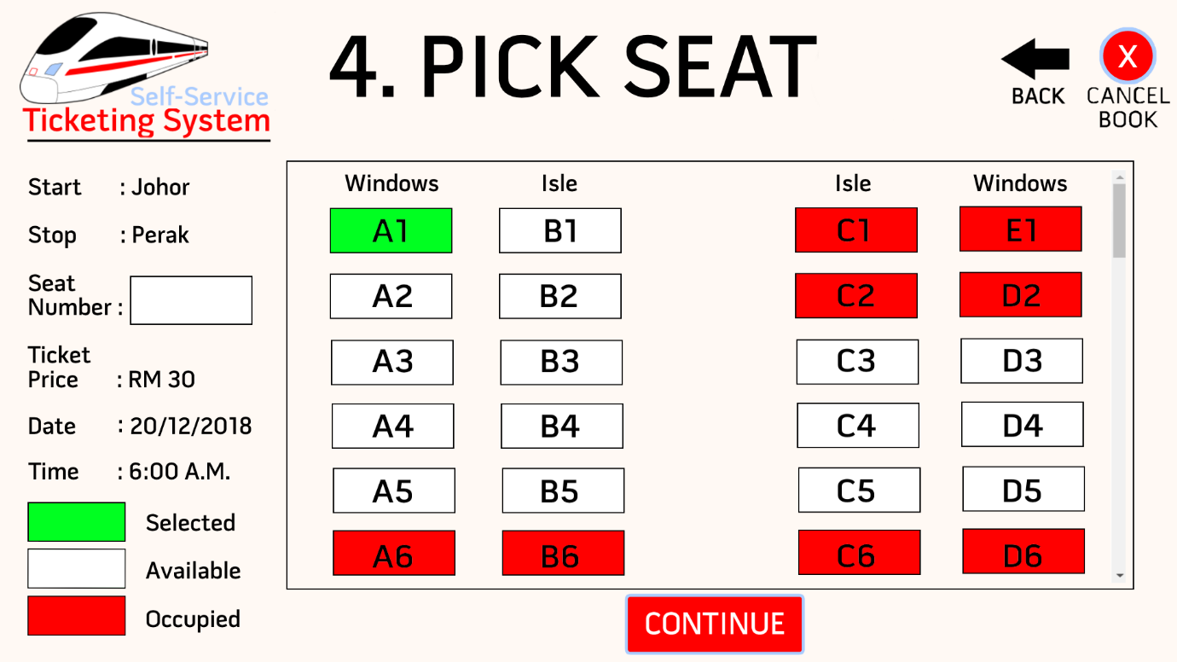

#### 8.4.8.2 Pick Seat Page 2(Depart)

The figure below shows the Pick Seat page that will be displayed when the user wants to book a two-way ticket. In this page, user can choose the seat for the depart train journey. The page works exactly like the one-way ticket Pick Seat Page.

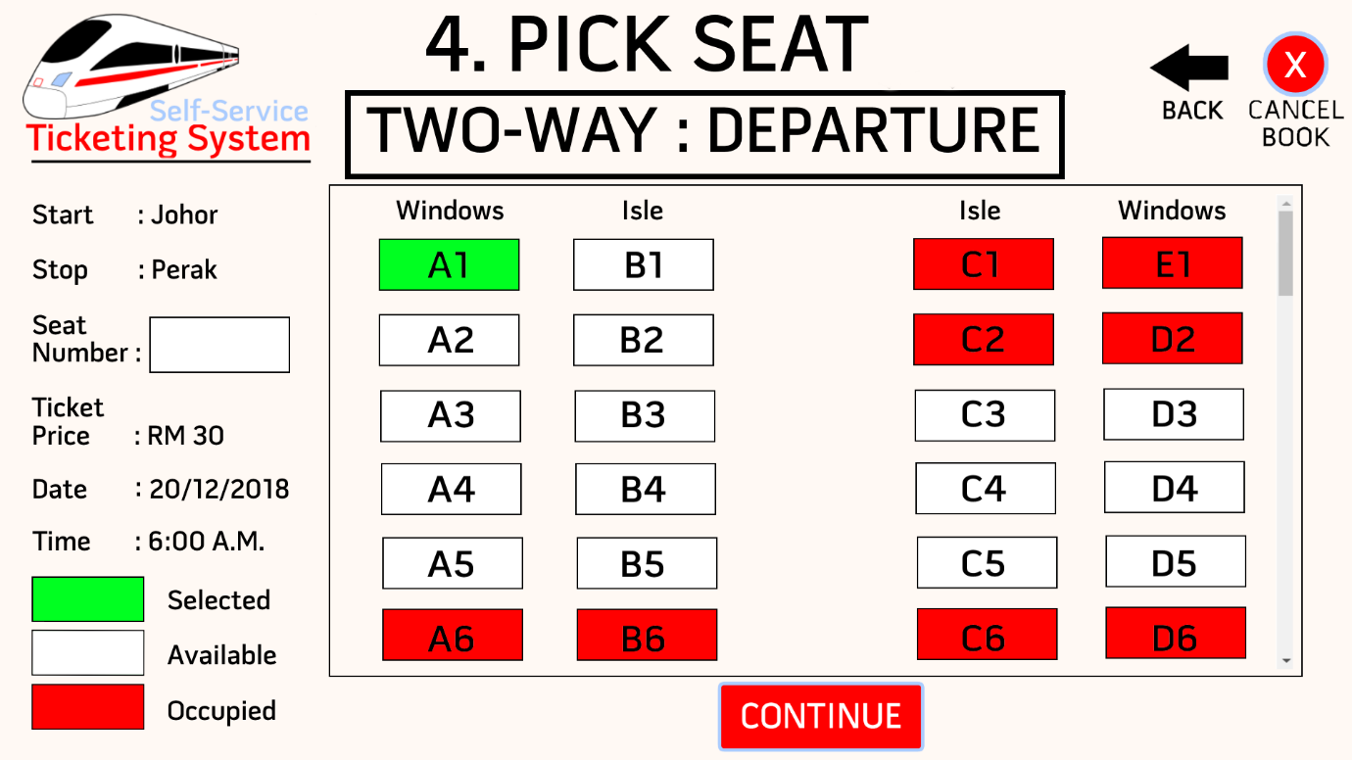

#### 8.4.8.3 Pick Seat Page 2(Return)

The figure below shows the Pick Seat page that will be displayed when the user wants to book a two-way ticket. In this page, user can choose the seat for the return train journey. The page works exactly like the one-way ticket Pick Seat Page.

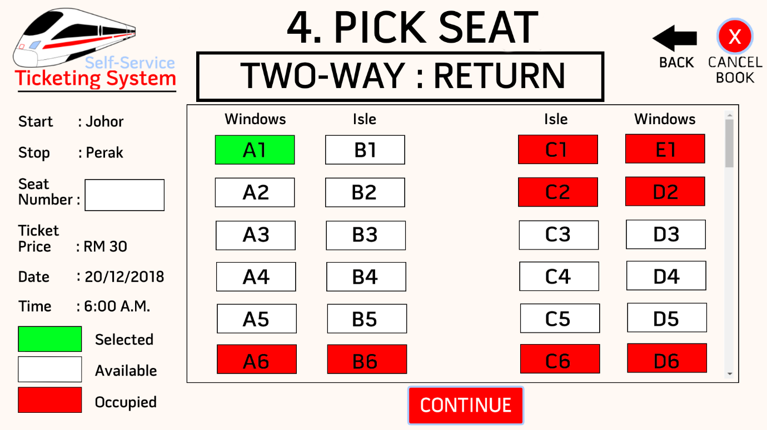

### 8.4.9 Payment Page

The figure below is a graphical representation of the Payment page. In this page, every detail of the user’s choices will be displayed and the user can review the choices the user made for train ticket before making a payment. Three buttons are placed in the bottom of the page for the user to pick the user’s desired payment method. Every button will direct the user to the make payment for the ticket using their desired payment method. If the user decided to cancel booking, user can press the Cancel Book button and will be redirected back to the Home page. And if the user decided to go back to the previous page, user can press the Back button and the program will redirect the user to the previous page.

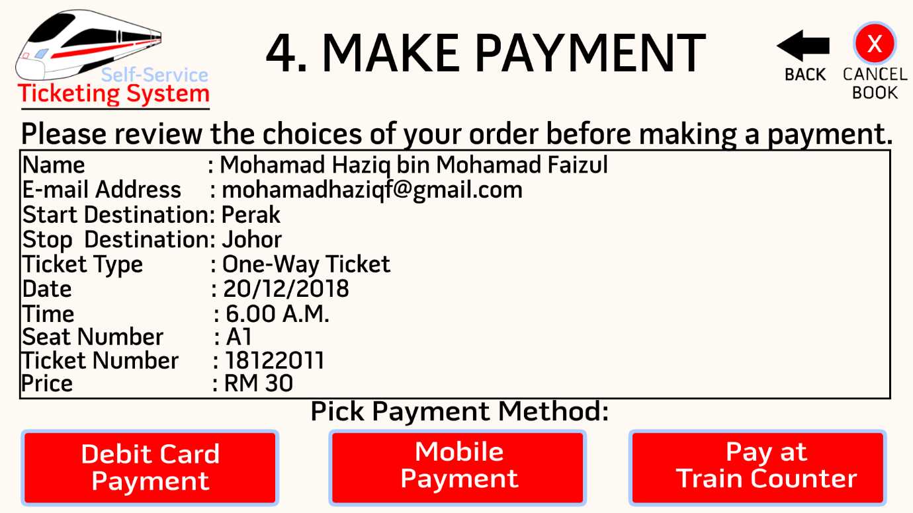

### 8.4.10 Final Print Page

The figure below is a graphical representation of the Final Print page. In this page, the program will display every important detail of the train ticket that the user bought. User can print ticket receipt by pressing the Print Ticket Receipt button. User can also print train ticket by pressing the Print Train Ticket button. If the user wants to book another ticket and use the program again, use can click the home button on the top-right of the page and the user will be redirected to the home page.

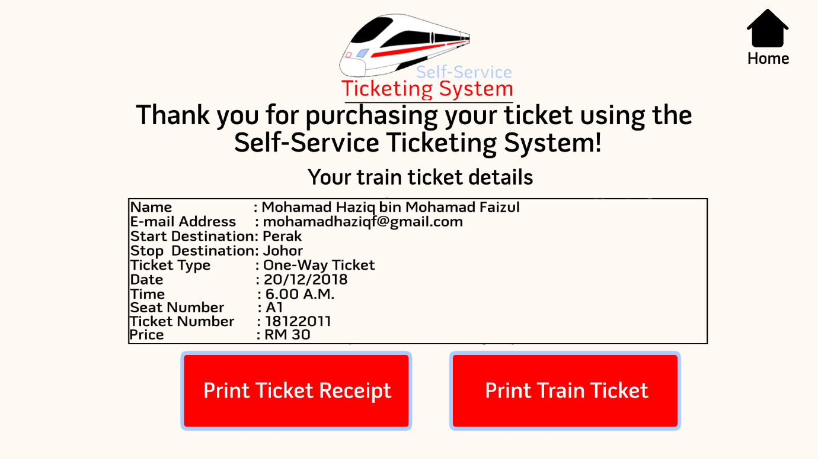

### 8.4.11 Ticket Receipt

The figure below is a graphical representation of the Ticket Receipt. Every important details of the booked train ticket and the payment amount will be included in the receipt.

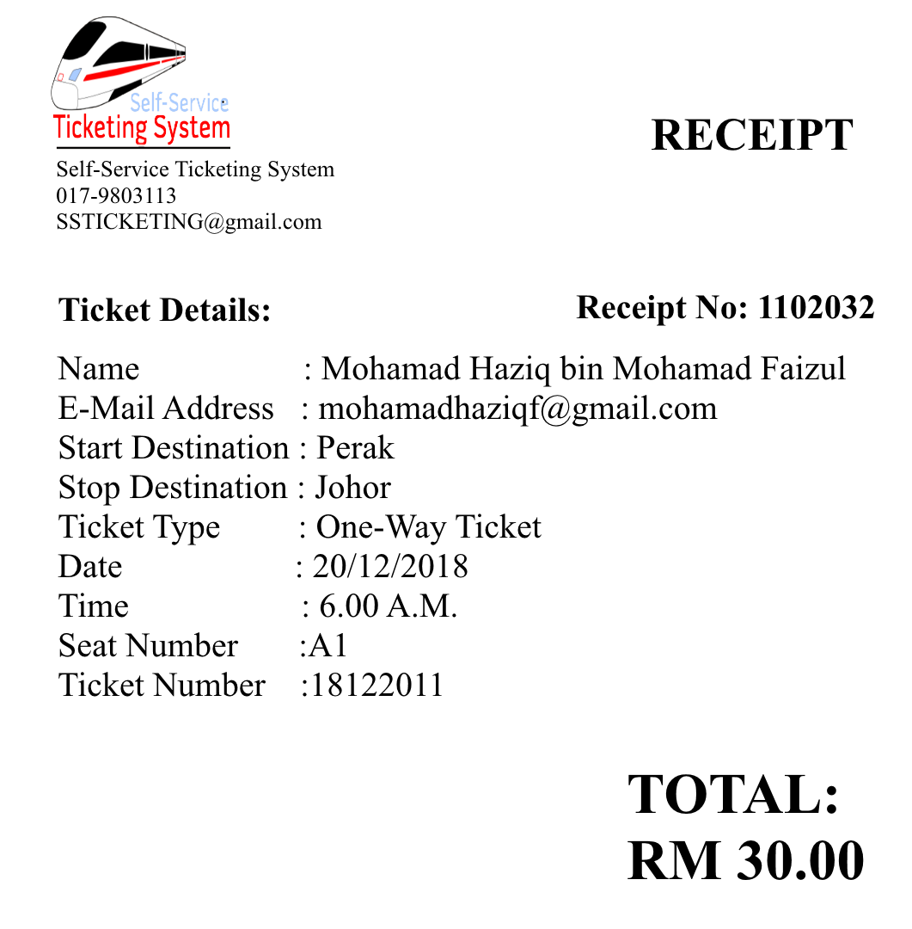

### 8.4.12 Train Ticket

The figure below is a graphical representation of the Train Receipt. Every important details of the booked train ticket will be included in the ticket for the user to be able to enter the train.

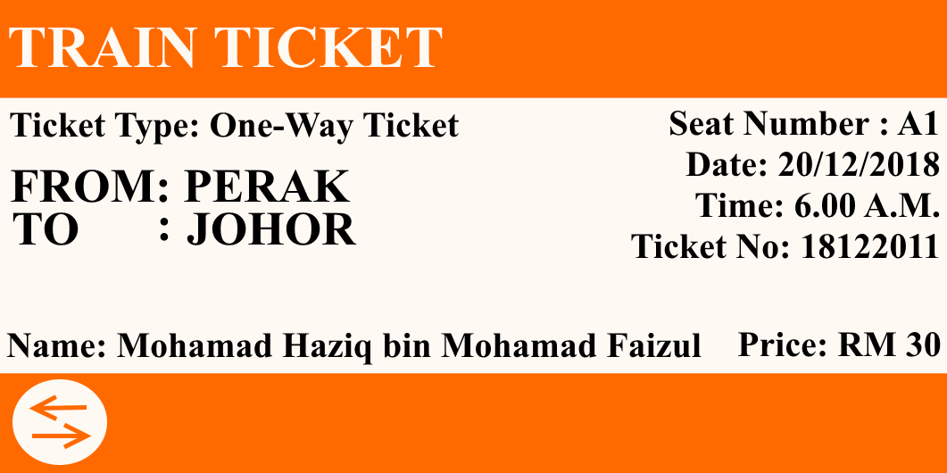

### 8.4.13 Links Used in Making the User Interface Design

https://www.onlinewebfonts.com/icon/56128

http://simpleicon.com/phone-symbol-2.html

http://www.free-icons-download.net/back-logo-icon-72763/

<http://www.free-icons-download.net/home-button-icon-73296/>

## 8.5 Internal Logic

Having a professional and highly accurate logic of a system will defiantly help to build a great system to do its desired work. So in this section and its upcoming sub-sections, we explained how the system’s logical functions work as flowcharts and pseudocode such as the home page and choosing seats, to optimise the Self-Service Ticketing System for Train system fully without any incontinence caused.

### 8.5.1 Flowchart

#### 8.5.1.1 Home Page Flowchart

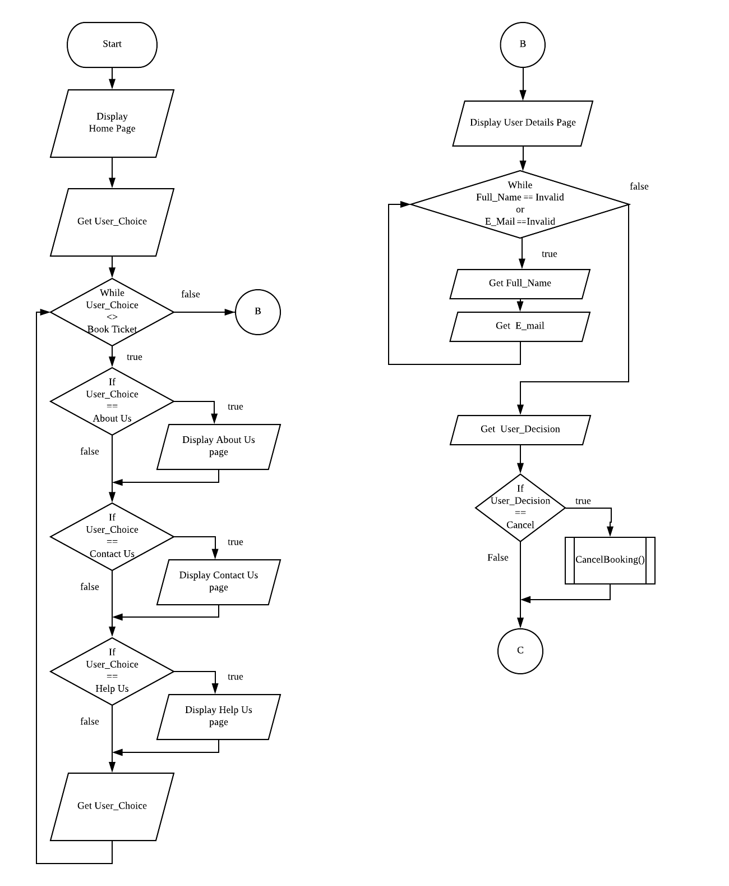

The flowchart above is a representation of the flow of the first module in the program. The module starts with displaying the Home page which can be seen by the program user (refer to 8.4.1 in the document for graphical representation). The program will ask the users choice; booking a ticket, opening the About Us page (refer to 8.4.2 in the document for graphical representation), Help page (refer to 8.4.3 in the document for graphical representation) or Contact Us page (refer to 8.4.4 in the document for graphical representation). If the user wants to book a ticket, the user will be directed to the first booking module. Otherwise, user can go to the other pages non-linearly and as many times as the user wants until the user wants to book the ticket.

#### 8.5.1.2 User Details Page



The flowchart above is a representation of the flow of the first module in the booking section of the program. The module starts with displaying the User Details page which can be seen by the program user (refer to 8.4.5 in the document for graphical representation). The user then has to put in the user’s full name and E-mail address. If the user input has an error, the program will detect the error and asks the user to put in the user’s full name and E-mail address again. If the user chooses to cancel its booking, the user will be redirected back to the home page. Otherwise, the user can continue to the next page only when there is no error in the input.

#### 8.5.1.3 Destination Page Flowchart

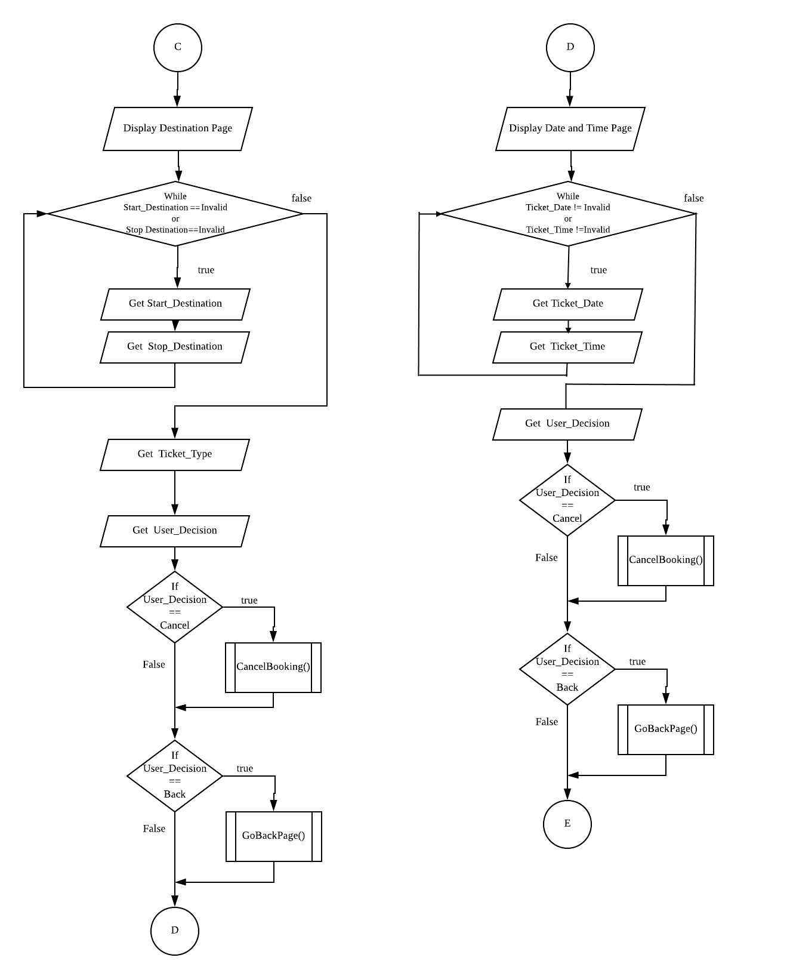

The flowchart above is a representation of the flow of the second module in the booking section of the program. The module starts with displaying the Destination page which can be seen by the program user (refer to 8.4.6 in the document for graphical representation). The user then has to put in the user’s start destination and the stop destination. If the input has an error, the program will detect the error and asks the user to put in the start destination and stop destination again. The user then has the choice to pick the ticket type; one-way ticket or two-way ticket. If the user wants to go back to the previous page, the program will redirect the user back to the User Details Page. If the user chooses to cancel its booking, the user will be redirected back to the home page. Otherwise, the user can continue to the next page only when there is no error in the input.

#### 8.5.1.4 Date and Time Page Flowchart

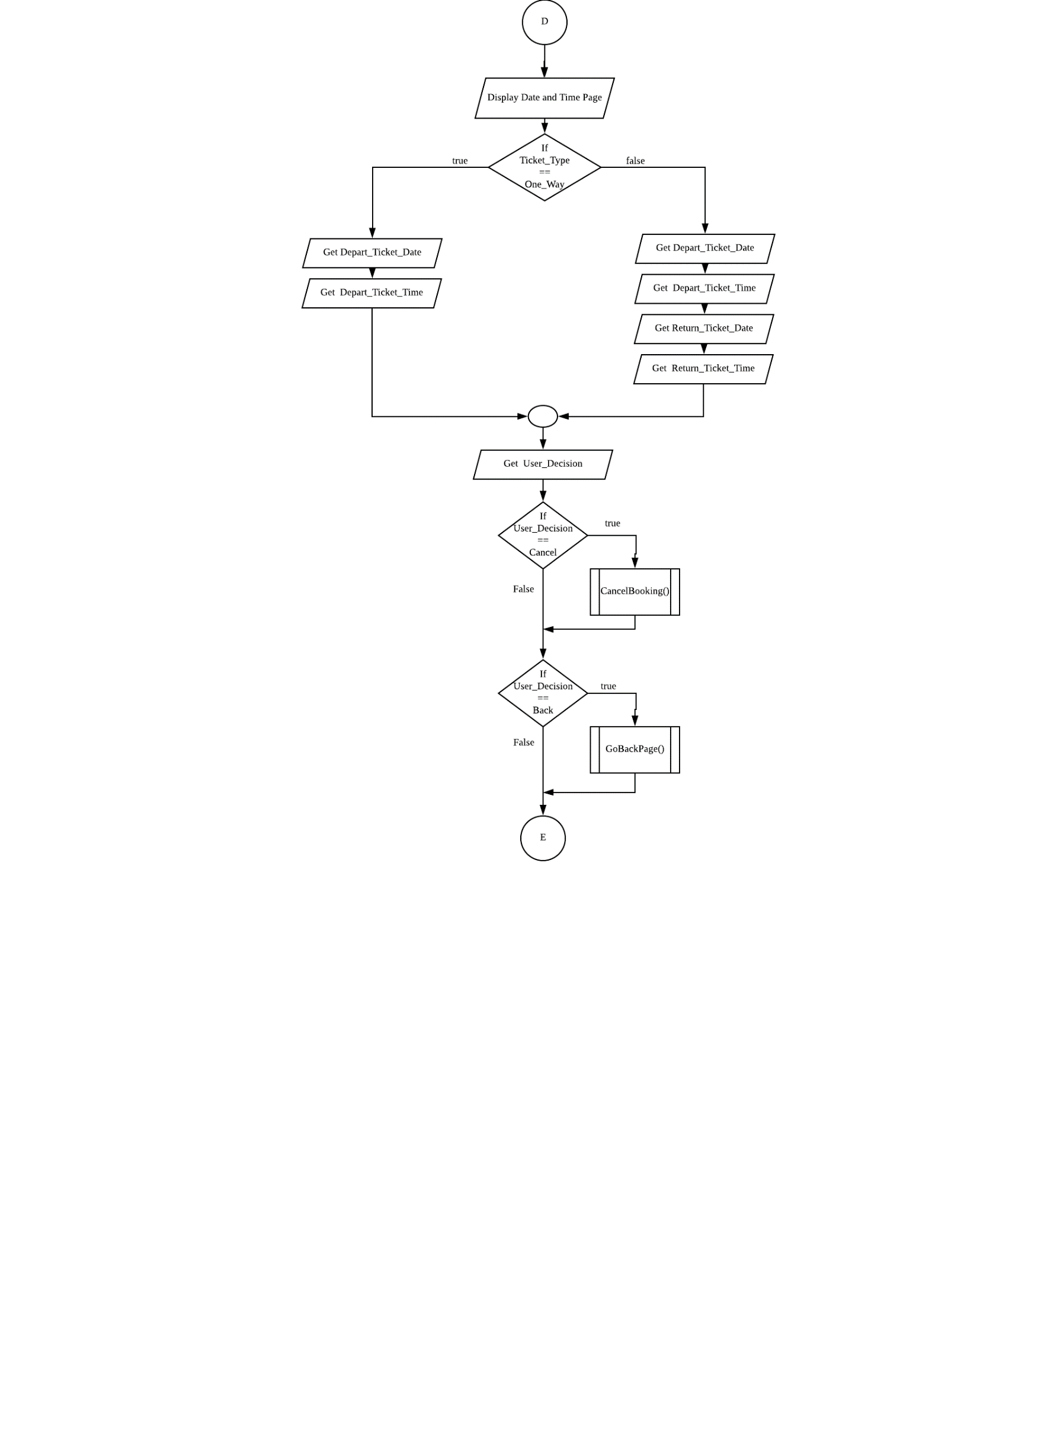

The flowchart above is a representation of the flow of the third module in the booking section of the program. The module starts with displaying the Date and Time page which can be seen by the program user (refer to 8.4.7 in the document for graphical representation). If the user chose a one-way ticket, the user then has to put in the user’ desired date and time for the depart train journey. If the user chose a two-way ticket, the user then has to put in the user’ desired date and time for the depart train journey and the return train journey. If the user wants to go back to the previous page, the program will redirect the user back to the Destination Page. If the user chooses to cancel its booking, the user will be redirected back to the home page. Otherwise, the user can continue to the next page.

#### 8.5.1.5 Pick Seat Page Flowchart



The flowchart in the previous page is a representation of the flow of the fourth module in the booking section of the program. The module starts with displaying the Pick Seat page which can be seen by the program user (refer to 8.4.8 in the document for graphical representation). If the user chose a one-way ticket, the user then has to put in the user’ desired seat for the depart train journey. If the user chose a two-way ticket, the user then has to put in the user’ desired seats for the depart train journey and the return train journey. If there is an error in the input, the program will detect the error and asks the user to put in the user’s choices again. If the user wants to go back to the previous page, the program will redirect the user back to the Date and Time Page. If the user chooses to cancel its booking, the user will be redirected back to the home page. Otherwise, the user can continue to the next page only when there is no error in the input.

#### 8.5.1.6 Payment Page Flowchart

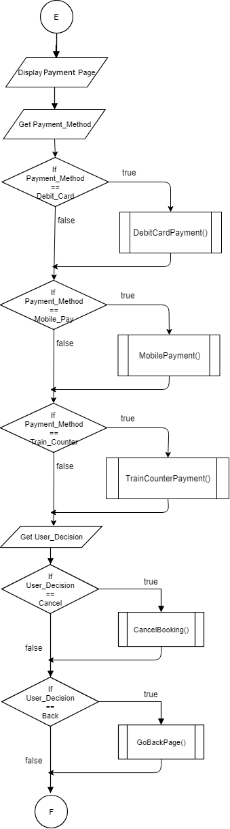

The flowchart in the previous page is a representation of the flow of the fifth module in the booking section of the program. The module starts with displaying the Payment page which can be seen by the program user (refer to 8.4.9 in the document for graphical representation). User can choose to pay either with debit card, mobile payment or pay at train counter. If the user wants to go back to the previous page, the program will redirect the user back to the Pick Seat Page. If the user chooses to cancel its booking, the user will be redirected back to the home page. Otherwise, the user can be directed to the payment of their choice.

#### 8.5.1.7 Final Print Page Flowchart



The flowchart above is a representation of the flow of the last program. The module starts with displaying the Final Print page which can be seen by the program user (refer to 8.4.10 in the document for graphical representation). User can choose to print their train ticket. User can also choose to print their train receipt. If the user wants to book another ticket using the program, the user will be redirected back to the home page.

### 8.5.2 Pseudocode

**User Start the Program**

**User Input Option**

**If Option = Help**

**Output Help_Message**

**End If**

**If Option = Contact Us**

**Output Contact_Us_Message**

**End If**

**If Option = About Us**

**Output About_Us_Message**

**End If**

**If Option = Book**

**Do**

**Output ‘Enter Your Name’**

**Output ‘Enter Your E-mail’**

**Input Name**

**Input Valid Email**

**While Not Valid Name or Email**

**Do**

**Output ‘Select Start Destination, Stop Destination’**

**Output ‘1. One Way 2. Two Way'**

**Input Start Destination**

**Input stop Destination**

**Input One Way or Two Way**

**While Not Valid Entry**

**If User Select One Way**

**Do**

**Output ‘Pick Seat’**

**Input seat**

**While Available Seat**

**End If**

**Else If User Select Two Way**

**Do**

**Output ‘Pick Seat Two Way Depart’**

**Input Depart Seat**

**While Available Seat**

**Do**

**Output ‘Pick Seat Two Way Return’**

**Input Return seat**

**While Available Seat**

**End If**

**Output User Information**

**Output 'Select Payment Method'**

**Output '1. Debit Card'**

**Output '2. Mobile Payment'**

**Output '3. Pay at Train Counter'**

**Input Option**

**Output ‘Thank you For Purchasing Your Ticket’**

**Output ‘Your Ticket Detail’**

**Output ‘Print Ticket Train’**

**Output ‘Print Ticket Receipt’**

**Input Option**

**If Option = Print Ticket Train**

**Output Tieck Booked**

**Else If**

**Option = Print Ticket Receipt**

**Output Ticket Receipt**

**Program End**

# 9.0 Testing

Testing is one of the last few steps that needs to be taken when creating a software. It is usually done after implementing the system, to see whether the result of the program is as expected. It is also done to identify any problems on the system so developers could fix the problem later on.  
  
For our Self-service Train Ticketing System, we will test it out by going through test cases which would be based on decision table and the flowchart of the system.

## 9.1 Testing Functional Requirements

Prior to advancing in developing the self-service train ticketing system, the team listed a set of functional requirements that would be included in the system. The team believes that having these functional requirements would improve the overall experience in using the system. The team made sure that these requirements are achievable during the later phases when developing the system. After the implementation of the system, the team has to test all the functional requirements to find any possible error within the functional requirements. Functions are tested and examined to identify if the functions work as expected.

Some of the functions that will be tested are:

* Display information on the train system under the About Us segment of the system
* Display help section
* Display contact number of train system
* Display name and email on receipt and train ticket.
* Display routes map and the fares for the destination.
* Shows seats availability for users to choose when purchasing a train ticket.
* Offers option to select different dates and also two-ways ticket option when purchasing a ticket with the system.
* Multiple payment method
* Printing of train ticket and receipt

In the test case, the team will use the testing method of:

* Black-box testing
* Testing without having to know the internal structure of the system
* White-box testing
* Testing with reference to the internal structure of the system

## 9.2 Testing Non-Functional Requirements

In prior our team listed down some non-functional requirements in the system. Having these non-functional requirements will make the system easier to use and fulfil its requirements. Based in our knowledge and the survey we are pretty sure that they are achievable. After the implementing the prototype we have to test the system and its functions to identify the possible errors and anything can affect the user experience.

Below are the non-functional requirements and its appropriate way of testing for each one of them:

* **Efficiency**: To test efficiency the team have to make sure it is done to verify if the application works efficiently and the customer requirement, complexity, environment required and time. Testing efficiency would help to define how efficient the system is, if all the considered parameters worked as expected. I.e. purchasing two-ways ticket will ease users to purchase two tickets by using the system only once instead of twice.

* **Reliability**: Reliability tested by verifying that the application is tested for a specific period of time and reliable. Since the system give us the same output as expected every time we test it then it’s considered as reliable. I.e. the system detects errors occurred when the user chooses an invalid option such as picking a seat that has already been booked.

* **Usability**: To verify the learnability and memorability of usage of our GUI we used Hallway testing method where we asked random people to use our system and get their feedback. This testing is particularly important when testing the system GUI and evaluate it for human use. I.e. the system allows users to go back to previous sections and change any previous option chosen instead of starting the system all over again.

* **Accessibility**: Since our system is a self-service solution, testing the accessibility of the system can be done by addressing the users’ concerns and how easy the system can be used by people with varying capabilities. I.e. the system provides information on train system such as contact info which aids system users to solve problems when using the system.

* **Portability**: To test portability we installed the program on a different platform and it should be able to run as expected. It is required while testing to test the changes with the hardware configurations such as processor performance to ensure that the software has the correct behaviour and expected functionality are intact. I.e. the system can be used anywhere provided there is a computer system that has the standalone system included in it.

## 9.3 Decision Tables

Decision tables are tables that consist of actions to be done in a system under certain conditions. They are useful in testing a system. The decision tables below will be used later on in the test case.

### 9.3.1 User Enter Details

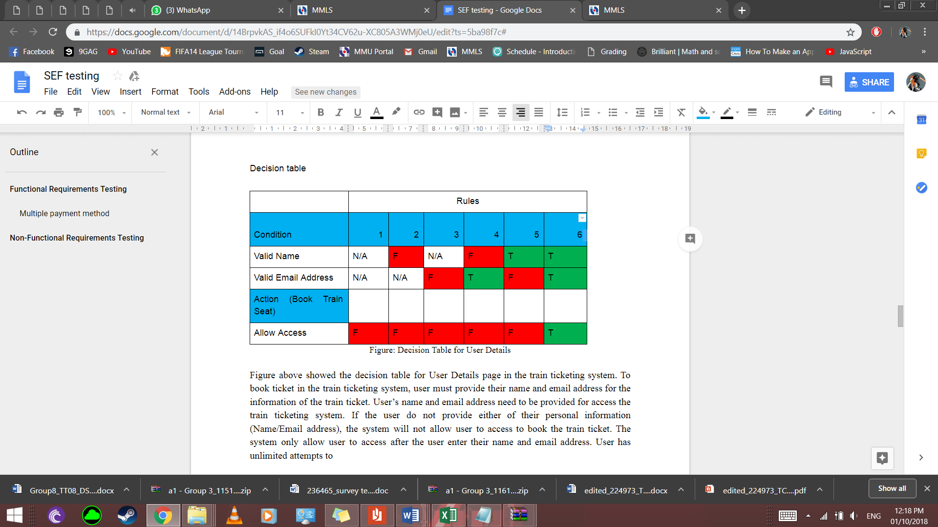

When a user wants to book a train ticket, the user must enter a valid name and e-mail address before being able to do so. The decision table above is a table to show all the possible condition and the expected actions when trying to input a user’s details.

### 9.3.2 User Picks Type of Ticket

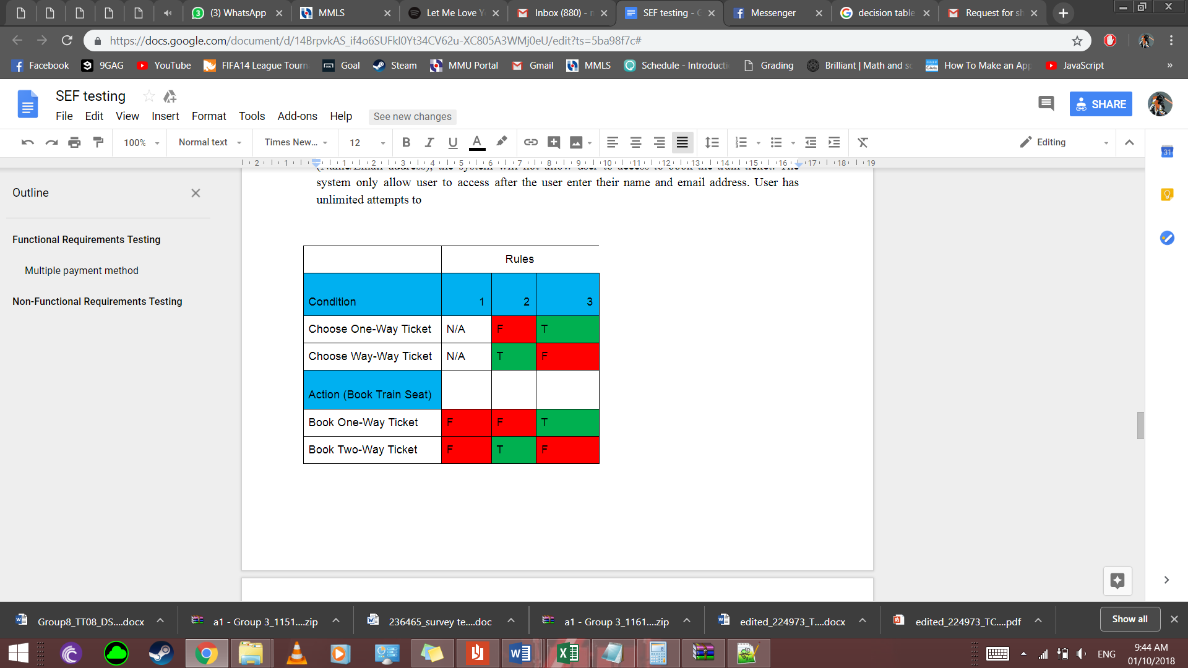

In the system, the user has an option to book a one-way ticket or a two-way ticket. The decision table above is a table to show all the possible condition and expected actions when trying to pick a type of ticket.

### 9.3.3 User Picks the Payment Method

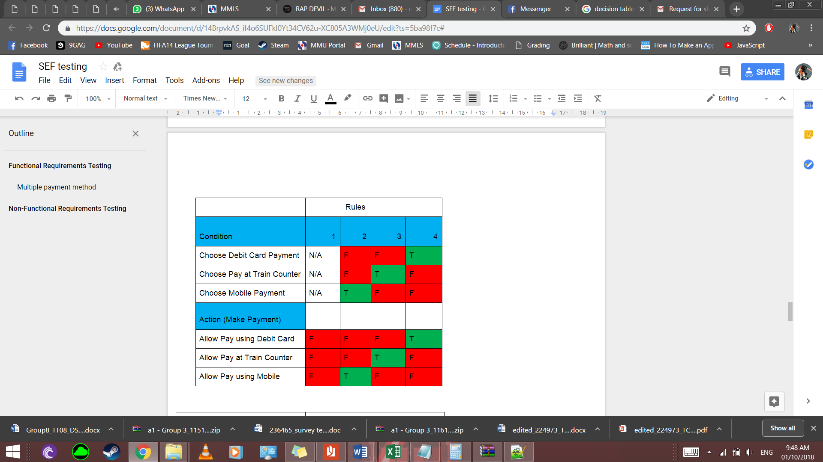

In the system, the user has an option to pay using debit card, pay using mobile payment or pay at the train station. The decision table above is a table to show all the possible condition and expected actions when trying to the payment option.

### 9.3.4 User Print Ticket or Print Receipt

|  |  |  |  |
| --- | --- | --- | --- |
|  | Rules | | |
| Condition | 1 | 2 | 3 |
| Choose Print Train Receipt | N/A | F | T |
| Choose Print Train Ticket | N/A | T | F |
| Action (Make Payment) |  |  |  |
| Print Train Receipt | F | F | T |
| Print Train Ticket | F | T | F |

In the system, user has the opportunity to print the train ticket, train receipt or both after making payment. The decision table above is a table to show all the possible condition and expected actions when user wants to print ticket or print receipt.

## 9.4 Test Case

### 9.4.1 User Enter Details

The test case will test out every possible condition for when the users input their name and e-mail in the system. The test will be created from the decision table of User Enter Details.



#### **9.4.1.1 Test Case #1 Do not enter name and e-mail address for the input.**

User submits nothing for the input and proceeds to continue to book page.

**Steps:**

1. Go to the User Details page
2. Leave the input spaces empty
3. Press continue
4. Observe the results

**Sample data**

* Full name (as per in IC):
* E-mail address:

**Expected results:** The program will display a message indicating that the entered data is invalid.

**Actual results:**

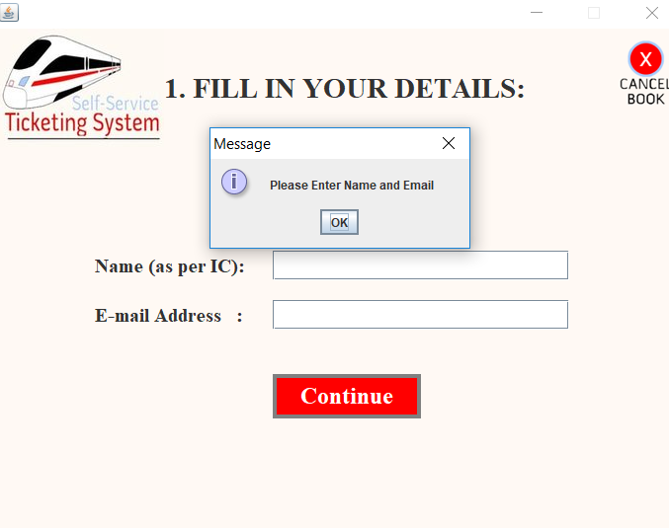

#### **9.4.1.2 Test Case #2 Enter an invalid name and no input for e-mail address**

User submits a name that the system does not accept and leaves the input blank for the e-mail address.

**Steps:**

1. Go to the User Details page
2. Enter an invalid name in the name input space
3. Leave the input space for e-mail address empty
4. Observe the results

**Expected results**: The program will display a message indicating that the entered data is invalid.

**Actual results:**

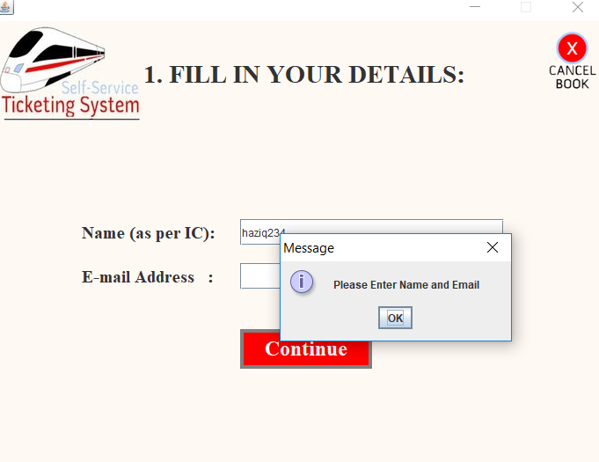

#### **9.4.1.3 Test Case #3 Enter an invalid email-address and no input for name**

User submits an e-mail that the system does not accept and leaves the input blank for the name.

**Steps:**

1. Go to the User Details page
2. Leave the input space for name empty
3. Enter an invalid name in the e-mail address space
4. Observe the results

**Expected results**: The program will display a message indicating that the entered data is invalid.

**Actual results:**

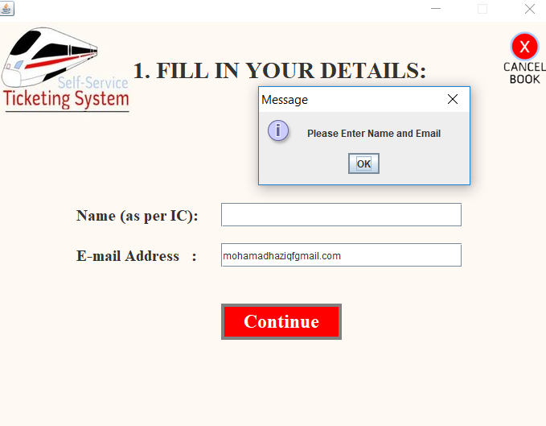

#### **9.4.1.4 Test Case #4 Enter an invalid name and a valid e-mail address**

User submits a name that the system does not accept and an e-mail address that is valid.

**Steps:**

1. Go to the User Details page
2. Enter an invalid name in the name input space
3. Enter a valid e-mail in the e-mail address input space
4. Observe the results

**Expected results**: The program will display a message indicating that the entered data is invalid.

**Actual results:**

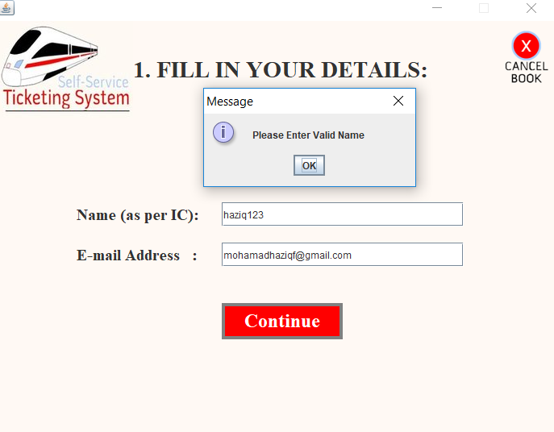

#### **9.4.1.5 Test Case #5 Enter an invalid e-mail address and a valid name**

User submits an e-mail that the system does not accept and a name that is valid.

**Steps:**

1. Go to the User Details page
2. Enter a valid name in the name input space
3. Enter an invalid e-mail in the e-mail address input space
4. Observe the results

**Expected results**: The program will display a message indicating that the entered data is invalid.

**Actual results:** 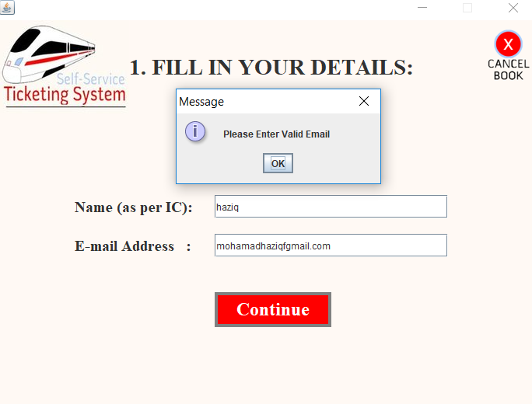

#### **9.4.1.6 Test Case #6 Enter a valid name and a valid e-mail address**

User submits a name and e-mail address that are valid.

**Steps:**

1. Go to the User Details page
2. Enter a valid name in the name input space
3. Enter a valid e-mail in the e-mail address input space
4. Observe the results

**Expected results**: The program accepts the input and directs the user to the other page.

**Actual results:**

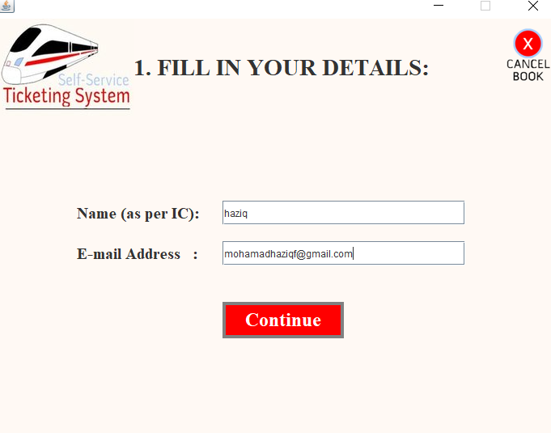

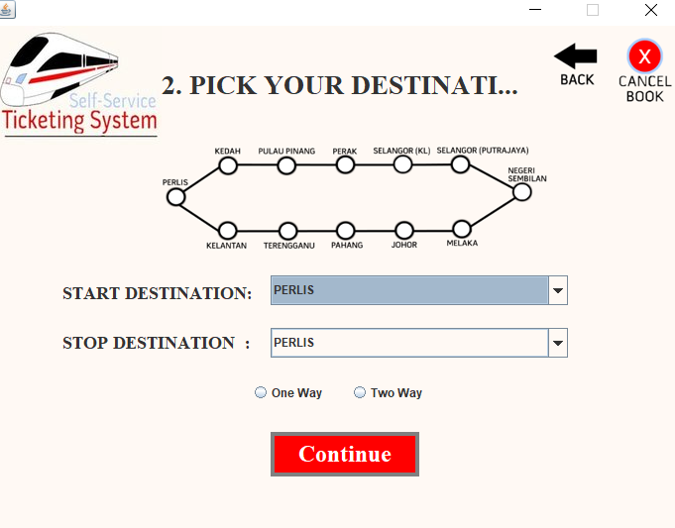

### 9.4.2 User Picks Type of ticket

The test case will test out every possible condition for when the picks a type of ticket when booking with the system. The test will be created from the decision table of User Picks Type of Ticket.



#### **9.4.2.1 Test Case #1 Do not pick any type of ticket**

User picks nothing for type of ticket and attempts to click continue.

**Steps:**

1. Go to the Destination page.
2. Do not click on one-way ticket or two-way ticket option.
3. Click continue.
4. Observe the results.

**Expected results:** The program will display a message indicating that the choice is invalid.

**Actual results:**

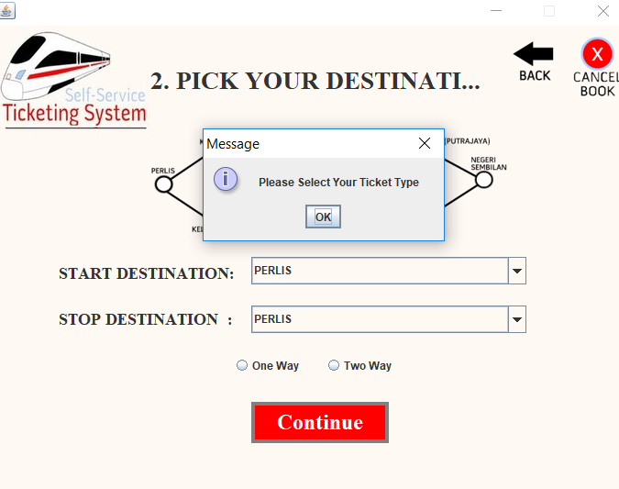

#### **9.4.2.2 Test Case #2 Choose Two-way ticket.**

User Two-way ticket and attempts to click continue.

**Steps:**

1. Go to the Destination page.
2. Click on the Two-way ticket option.
3. Click continue.
4. Observe the results.

**Expected results:** The program accepts the choice and directs the user to the Two-way ticket page.

**Actual results:**

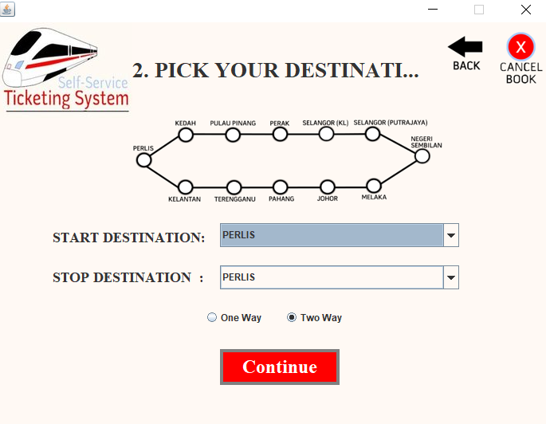

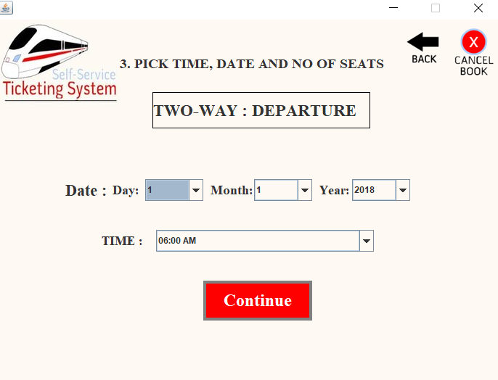

#### **9.4.2.3 Test Case #3 Choose One-way ticket.**

User One-way ticket and attempts to click continue.

**Steps:**

1. Go to the Destination page.
2. Click on the One-way ticket option.
3. Click continue.
4. Observe the results.

**Expected results:** The program accepts the choice and directs the user to the One-way ticket page.

**Actual results:**

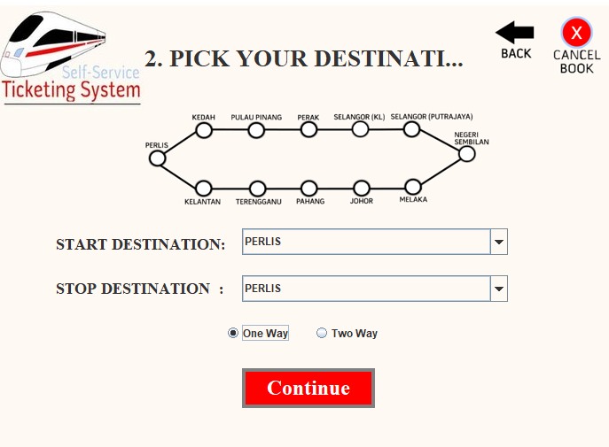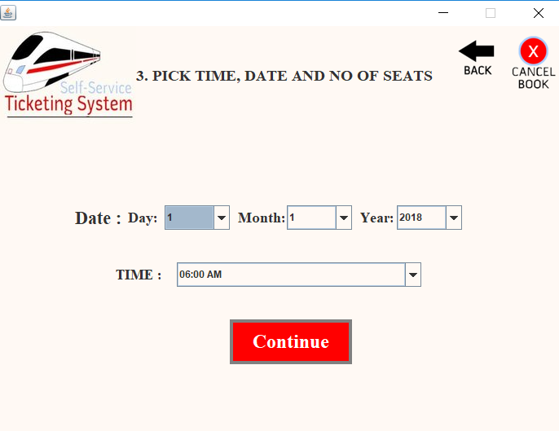

### 9.4.3 User Picks the Payment Method

The test case will test out every possible condition for when the picks a payment method when booking with the system. The test will be created from the decision table User Picks the Payment method.



#### **9.4.3.1 Test Case #1 Do not pick any choice of payment**

User clicks nothing for the choice of payment.

**Steps:**

1. Go to the Payment page
2. Do not click on any button on the page
3. Observe the results

**Expected results:** The program will not process anything.

**Actual results:**

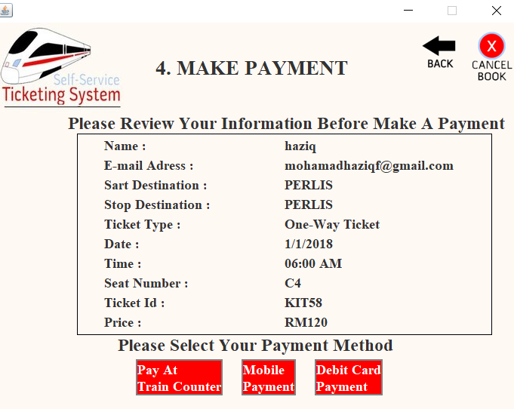

#### **9.4.3.2 Test Case #2 Pick Mobile Payment as payment**

User clicks the Mobile Payment button to pay with mobile.

**Steps:**

1. Go to the Payment page
2. Click on the Mobile Payment button
3. Observe the results

**Expected results:** The program will direct the user to the Mobile Payment page

**Actual results:**

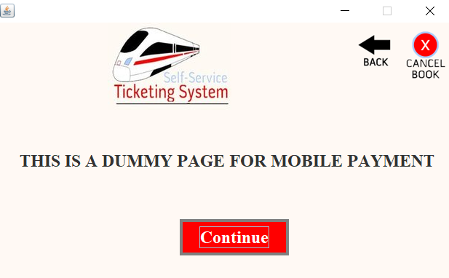

#### **9.4.3.3 Test Case #3 Pick Pay at Train Counter as payment**

User clicks the Pay at Train Counter button to pay at the train station.

**Steps:**

1. Go to the Payment page.
2. Click on the Pay at Train Counter button.
3. Observe the results.

**Expected results:** The program will direct the user to the Pay at Train Counter Payment page.

**Actual results:**

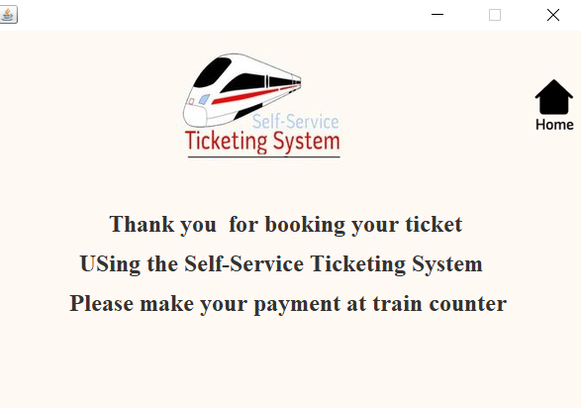

#### **9.4.3.4 Test Case #4 Pick Debit Card Payment as payment**

User clicks the Debit Card Payment button to pay with debit card.

**Steps:**

1. Go to the Payment page.
2. Click on the Debit Card Payment button.
3. Observe the results.

**Expected results:** The program will direct the user to the Debit Card Payment page.

**Actual results:**

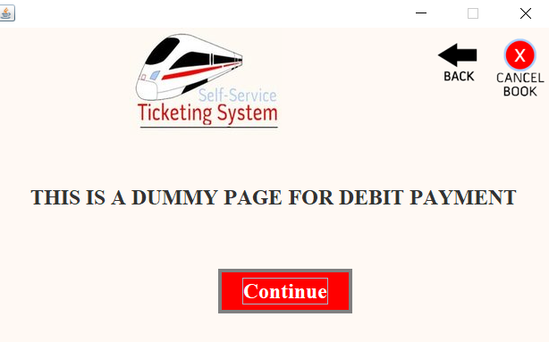

### 9.4.4 User Print Ticket or Print Receipt

The test case will test out every possible condition for when the user has the option to print ticket, print receipt or print both. The test will be created from the decision table User Print Ticket or Print Receipt.

|  |  |  |  |
| --- | --- | --- | --- |
|  | Rules | | |
| Condition | 1 | 2 | 3 |
| Choose Print Train Receipt | N/A | F | T |
| Choose Print Train Ticket | N/A | T | F |
| Action (Make Payment) |  |  |  |
| Print Train Receipt | F | F | T |
| Print Train Ticket | F | T | F |

#### **9.4.4.1 Test Case #1 Do not pick any option of printing**

User clicks nothing for the option to print.

**Steps:**

1. Go to the Final Printing page
2. Do not click on any button on the page
3. Observe the results

**Expected results:** The program will not process anything.

**Actual results:**

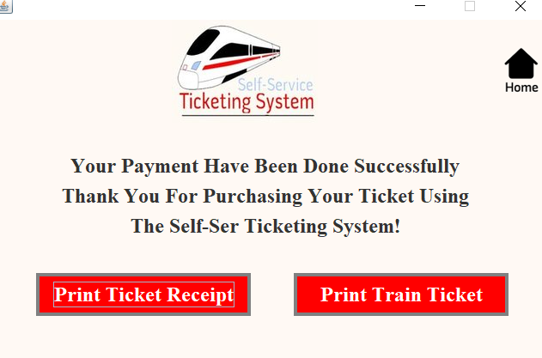

#### **9.4.4.2 Test Case #2 Pick Print Train Ticket**

User clicks the option to print train ticket.

**Steps:**

1. Go to the Final Printing page
2. Click on the Print Ticket button
3. Observe the results

**Expected results:** The program prints the train ticket.

**Actual results:**

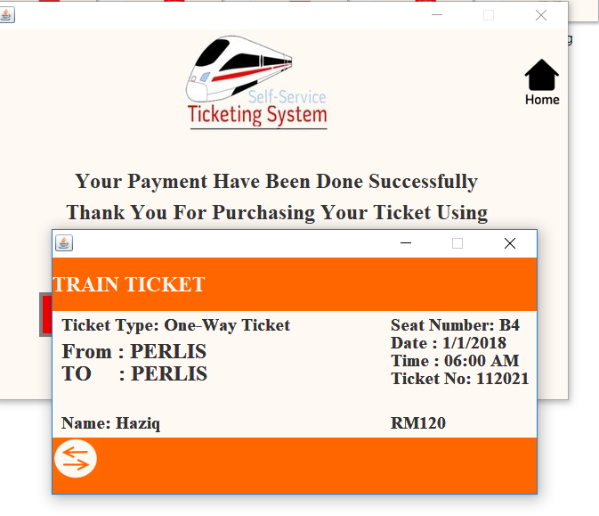

#### **9.4.4.3 Test Case #3 Pick Print Train Receipt**

User clicks the option to print train receipt.

**Steps:**

1. Go to the Final Printing page.
2. Click on the Print Ticket Receipt button.
3. Observe the results.

**Expected results:** The program prints the train receipt.

**Actual results:**

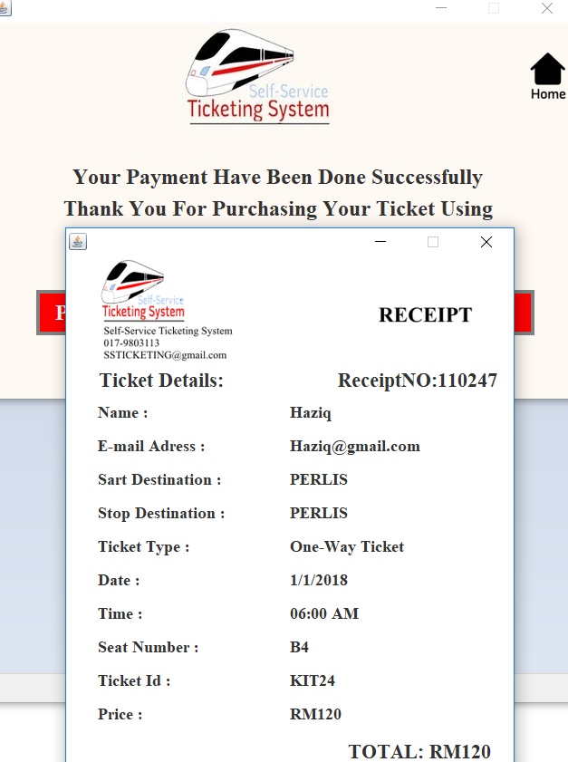

### 9.4.5 Display About Us, Contact Us and Help page.

About Us, Contact Us and Help Page are pages that can be seen by users to understand more about the system and allows them to contact the train company. Testing will be done to test out if these pages are displayed correctly as expected. The test is being done by referring to the flowchart.



**Steps:**

1. Go to About Us page, Contact Us page and help us page.
2. Identify any errors such as typography error.
3. Test out every button and see if it works correctly.
4. Observe the results.

**Expected results:** The pages contain no errors, and the buttons work out as expected.

**Actual results:**

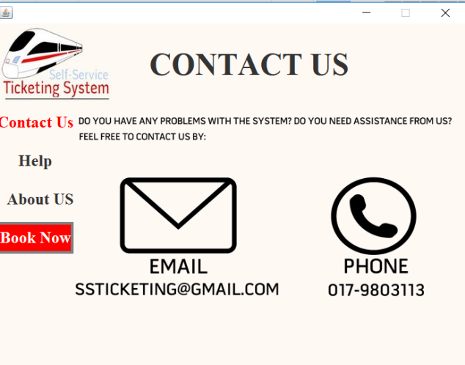

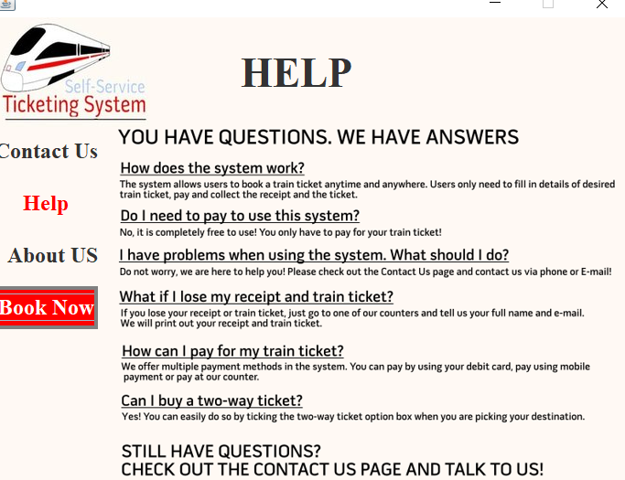

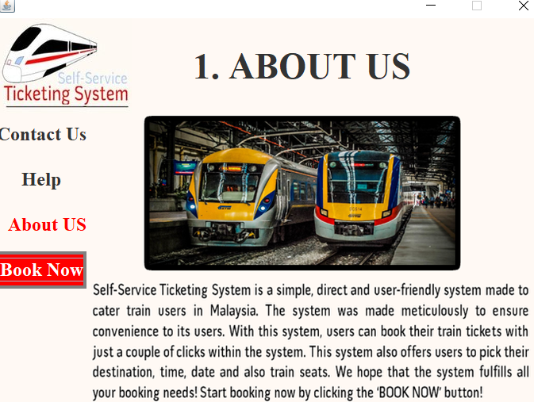

### 9.4.6 Display Routes Map and the Fare for the Destination

In the system, the user will be able to see the routes map in the Destination page, and the user can also see the fare on the Make Payment page. Testing will be done to make sure the system provides this function with no errors.

**Steps:**

1. Go to the Destination page and the Payment page.
2. Identify if the routes map and the fare for the destination can be seen in the system.
3. Check for errors in these features.

**Expected results:** The system contains route map and shows the fare for the destination without any error.

**Actual results:**

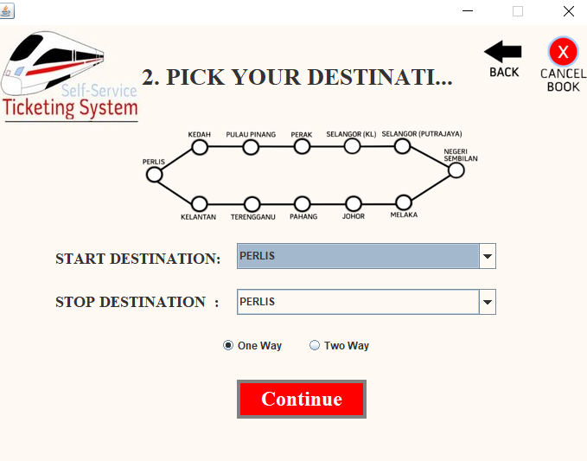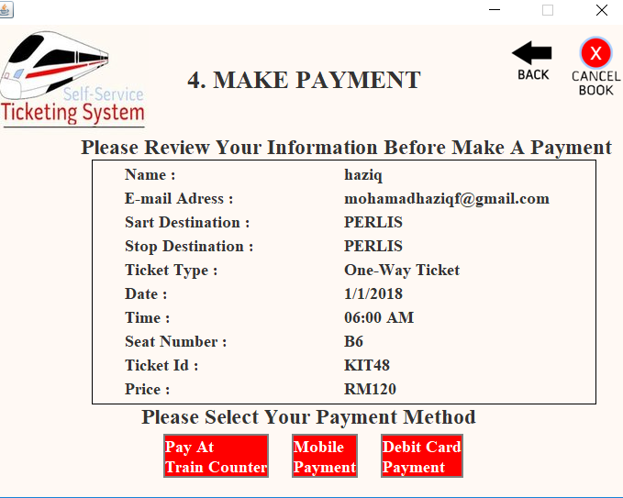

### 9.4.7 Shows Seats Availability

In the system, the user will be able to view available seats in the system. Testing will be done to make sure the system provides this function.

**Steps:**

1. Go to the Pick Seat Page
2. Identify if available seats can be viewed and be booked.
3. Identify if all the colour indication is true.

**Expected results:** The system allows the users to view available seats and be booked by the user.

**Actual results:**

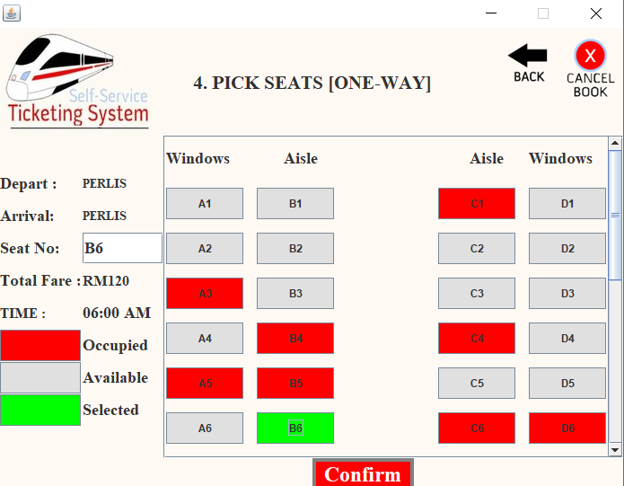

### 9.4.8 Display Name and E-mail Address in Train Ticket and Train Receipt.

In the system, the user will be able to view their names in the train ticket and train receipt. Testing will be done to make sure the system provides this function with no errors.

**Steps:**

1. Go to the Final Print Page.
2. Print train ticket and receipt.
3. Identify the name and e-mail can be seen in the ticket and receipt.
4. Identify if the name and e-mail match the input of the user.

**Expected results:** The system allows the users to view available seats and be booked by the user.

**Actual results:**

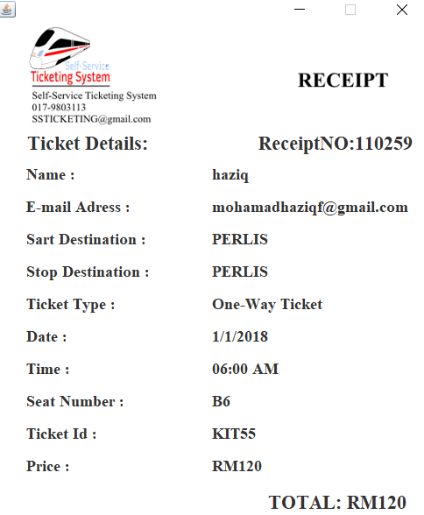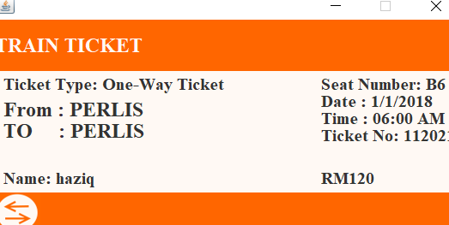

# Reference

Ellis, M. (2015, 1 29). *Record numbers of people use the train as 1.3BILLION trips made in just 12 months*. Retrieved from Mirror: https://www.mirror.co.uk/news/uk-news/record-numbers-people-use-train-5068779

Sami, M. (2017, May 14). *Software Scope vs. Requirement specifications*. Retrieved from melsatar.blog: https://melsatar.blog/2017/05/14/software-scope-vs-requirement-specifications/